Nottingham Trent University

School of Science and Technology

Cost-Effective, Feature-Rich Weather Station

by

Barry Jonathan O’Connor

in

2021

Project report in part fulfilment

of the requirements for the degree of

Bachelor of Science with Honours

in

Software Engineering

I hereby declare that I am the sole author of this report. I authorize the Nottingham Trent University to lend this report to other institutions or individuals for the purpose of scholarly research.

I also authorize the Nottingham Trent University to reproduce this report by photocopying or by other means, in total or in part, at the request of other institutions or individuals for the purpose of scholarly research.

Signature

Barry O’Connor

Abstract

The project attempts to investigate the need and market for an affordable weather station that has comparable sensor readings and features to those commercially available, with the emphasis on making a device that would be suitable and within the budget of small farmers whose livelihoods depend on their crop. The project also attempts to form a conclusion on whether mass-produced consumer electronics and microcontrollers are capable of this task.

The work explores the background of weather conditions and their effect on crops and uses this as a basis for selecting the array of sensors that make up the prototype.

In terms of the market, research and costings are carried out to discover where the gap in the market is and this price gap is used as a basis to select a budget for the project of £60 where all materials for the prototype weather station should be under this price.

The project was approached with an Agile project management style and a Test-Driven Development approach to testing. This was backed up by the use of a hardware-based methodology called Evolutionary Prototyping. The use of these combined resulted in an incremental process that was tested at each iteration and allowed for exploration of the unknown subject of electronics in a measured and reliable way.

The project aimed to allow the communication of local weather data through the use of sensors and a custom-designed Arduino implementation. When collected, the data would be sent via a SIM800L 2G GSM module to a server for storage and retrieval.

The final prototype did suffer from some issues with an intermittently faulty GSM modem module but testing did succeed in demonstrating that the results were recorded on the server and that the weather station prototype did in fact function as intended. Overall the project was successful but time spent on hardware issues resulted in a loss of the web frontend intended for the project.

Acknowledgements

I would like to thank my supervisor, Dr Neil Sculthorpe for his advice during the duration of this project. I hope the experience of your first hardware-based project hasn’t completely put you off further such projects.

I would like to thank my family and friends who have been endlessly supportive during my time at university and always there for me, whether that be a shoulder to cry on or the promise of a coffee and a chat. I love you all.

My thanks also go to my dear friend Darren, who shared his house and endless patience with me during Lockdown and whose weekly cooking of a Sunday roast while I worked was very often the highlight of my week.

I would like to dedicate this project to the memory of my Mother, Mary, who sadly passed away during my first attempt at university. She never got to see me graduate although I know she would be immensely proud if she had.

Table of Contents

CHAPTER 1 1

Introduction 1

1.1 Introduction 1

1.2 Problem Statement 2

1.3 Aims and Objectives 3

1.4 Report Chapters 3

1.4.1 Context 4

1.4.2 New Ideas 4

1.4.3 Implementation 5

1.4.4 Results 5

1.4.5 Conclusions and Future Work 5

CHAPTER 2 7

CONTEXT 7

2.1 Introduction 7

2.2 Previous Work 7

2.3 Weather 9

2.3.1 Temperature 10

2.3.2 Wind speed 11

2.3.3 Rainfall 12

2.3.4 Humidity 13

2.3.5 Air Pressure 14

2.3.6 Pests 15

2.4 Climate Change 16

2.5 Communication methods 17

2.5.1 WiFi (Wireless Fidelity / Wireless Local Area Network) 17

2.5.2 Mobile Data (GSM/LTE) 17

2.5.3 Radio Frequency Communication 19

2.5.4 LoRa (Long Range WiFi) 20

2.6 Market Research 21

2.6.1 Commercial Weather Sensors 21

2.6.2 Kit Based Weather Sensors 23

CHAPTER 3 28

New Ideas 28

3.1 Introduction 28

3.2 Feasibility of the Project. 28

3.2.1 Financial Feasibility 28

3.2.2 Hardware and Software Choices. 30

3.3 Potential Issues 32

3.3.1 Power 33

3.4 Safe Operating Temperatures 34

3.4.1 General Electronics 34

3.4.2 Microcontrollers 35

3.5 Methodology 36

3.6 Requirements 38

3.7 Automated Process Flow Chart 39

CHAPTER 4 41

IMPLEMENTATION or INVESTIGATION 41

4.1 Introduction 41

4.2 Important Electronics Terminology 42

4.2.1 Voltage Common Collector (VCC) and Ground (GND) 42

4.2.2 Receive (RX) and Transmit (TX) 42

4.2.3 I2C Communication 43

4.3 Sprint 1 43

4.3.1 Prototypes 44

4.4 Software and Testing 46

4.5 Sprint 2 47

4.6 Understanding the Prototype 49

4.6.1 Batteries 49

4.6.2 Solar Panel 50

4.6.3 TP4056 Charging / Battery Protection Circuit 50

4.6.4 Veroboard 50

4.6.5 Enclosure 51

4.6.6 Dual Temperature Sensors 51

4.6.7 Rain Sensor 52

4.6.8 Buck Converter 52

4.6.9 SIM800L GSM Module 53

4.6.10 Atmega328P Microcontroller 53

4.6.11 NEO-6M GPS Module 54

4.7 Software and Testing 55

4.8 Issues in Sprint 2 57

4.8.1 Library Issues 57

4.8.2 SIM800L Issues 58

4.8.3 Dynamic Memory Allocation Issues 59

4.8.4 Communication Issues 61

4.9 The decision to Introduce Sprint 3 61

4.10 Sprint 3 63

4.10.1 A Tale of Two Modules 64

4.11 Costings 66

CHAPTER 5 68

RESULTS / DISCUSSION 68

5.1 Introduction 68

5.2 Results 68

5.2.1 Investigating Whether the Hardware was Sufficient to support the Weather Station 68

5.2.2 Costings 69

5.2.3 Power 70

5.2.4 Weather Proof Enclosure 71

5.2.5 Collection of Data on the Server 72

CHAPTER 6 74

CONCLUSIONS / FUTURE WORK 74

6.1 Conclusions 74

6.2 Future work 75

6.2.1 Hardware Focus 75

6.2.2 Software Focus 77

6.2.3 Data Analysis 78

6.3 Legal, Social, Ethical and Professional Issues 79

6.3.1 Legal 79

6.3.2 Social 79

6.3.3 Ethical 81

6.3.4 Professional 81

6.4 Synoptic Reflections 83

List of Figures

Figure 1 - Differences between waterlogged and non-waterlogged soil 13

Figure 2 - IdeaSpark Weather Station Kit 24

Figure 3 - SparkFun micro:climate 26

Figure 4 - Surface Mounted versus Dual Inline Package 31

Figure 5 - Process Flow Chart 40

Figure 6 - A BME280 sensor connected to an Arduino Uno 44

Figure 7 - Database Diagram 47

Figure 8 - Prototype Design 48

Figure 9 - Prototype 1 49

Figure 10 - NMEA Sentences 54

Figure 11 - Class Diagram 57

Figure 12 - Output Issues Highlighted in Logs 59

Figure 13 - Improved Prototype Weather Station 63

Figure 14 - SIM800L Logs 64

Figure 15 - Original SIM800L Logs 66

Figure 16 - Costings Total 67

Figure 17 - Final SDRAM Usage 69

Figure 18 - Demonstrating Charging via Solar Panel 70

Figure 19 - Simulating Rainfall and Displaying Areas Where Water Collects Externally 71

Figure 20 - Captured Data in the Database 73



Introduction

Introduction

Farming is something that has become two-tier in today’s society with large, multinational businesses dominating commercial growth and commanding vast sums of money to micromanage crops to ensure that the harvest is as high a yield as possible to maximise profits. Intensive farming such as this is needed to feed a growing global population and a lot of research and technological discovery is dedicated to maximising yield. Part of that is the introduction of Automated Weather Stations, which monitor the weather conditions in fields and greenhouses and allow for warnings and informed choices to be made with regards to the health of the crop. These devices have become a mainstay of the industry and it’s difficult to imagine a time when greenhouses were not climate controlled. These devices are expensive though and while the benefits are obvious for large scale businesses, these do not make up the full farming picture.

On the other end of the spectrum sits the independent farmer. Their farms can range in size and depending on the available land, so can their expected profits. For the very small-scale farmer, typically those in less developed parts of the world, the cost of a modern weather station is many times the income of their farm and so there is a divide between these two markets based on money. It is also important to imagine the very small farmer, whose small plot of land which is worked manually provides the sole source of food for their family, with perhaps any excess being sold for a small profit.

Should a crop fail for a large scale farmer, there is generally enough funding available to survive this and in richer countries, even smaller farmers can potentially have insurance (NFU Mutual., 2021) in place to protect against this possibility. Large manufacturers who rely on farming as part of their production chain will often have the option of buying abroad and importing if a break in their supply chain happens. This cannot be said for smaller farmers whose entire livelihood and even ability to feed their family is at risk every time a crop fails and for whom the cost of insurance is simply too expensive.

In undertaking this project it was seen that those with the weather stations almost don’t need the technology since they could survive crop failure, while those in the most need of some ability to monitor their crops simply cannot afford the means to do so.

With the boom of consumer microcontrollers and cheap mass production of electronics capable of performing custom tasks, there could be a case made for using these components to create a cost-effective weather station aimed at these farmers who traditionally would not have the income needed to buy a commercial weather station.

## Problem Statement

This project will seek to solve the question of whether it is possible to create a cost-effective yet feature-rich weather station using readily available electronic components. This will have a special focus on the cost of the components due to the aimed audience and an effort will be made to research the market and discover if a pricing gap exists and whether a budget within that pricing range can create something which can mirror the features of commercially available solutions.

## Aims and Objectives

This project aims to investigate the viability of a low cost yet feature-rich weather station and to use research gathered to create a viable prototype and accompanying software.

The objectives for this project are as follow:

* Creating a low cost, feature-rich hardware prototype for an automatic weather sensor aimed at developing countries or small, low-income farmers which will post sensor data to a server API for storage and analysis.
* Creating a weatherproof prototype that can withstand the elements.
* Investigating whether the chosen hardware chosen is sufficiently powerful to perform the required task.
* Creating accompanying client and server software to record and analyse the data from the sensor and access restful API weather services to facilitate weather alerts for the farmer.

such a weather station by investigating the impact of weather conditions on crops, laying solid foundations on which to base the selection of which weather conditions to measure. Using market data to investigate whether there is room in the market for such a device will be key

## Report Chapters

This report is broken down into six main chapters inclusive of this introductory chapter, each with a corresponding focus on specific areas of the project and the development of the weather station.

### Context

This chapter will be used to present research important to the feasibility of the weather station and several key areas which will affect the development choices taken. This will include the discussion of the effects of weather conditions upon crops in general to highlight key weather conditions that the weather station should record. Market research will help to highlight the range of products available commercially and will include kit-based options to help discover if there is a gap in the market for a weather station such as that proposed and will further inform the budget for the project. Information about the various options for communication and microcontrollers will be presented and this will form the basis for the selection of the core hardware components for the prototype.

### New Ideas

In the New Ideas chapter, the primary focus will be on the design and planning involved in the proposed solution. In this chapter, the feasibility and need for the weather station will be discussed, some discussion surrounding the perceived issues inherent in the project is included as are justifications for budget, hardware and software choices. With these choices fleshed out, the project methodology is discussed and the use of Test-Driven Development as a testing strategy and Evolutionary Prototyping as a hardware development methodology is introduced.

This chapter will continue to cover the requirements of the system and a process flow will be used to give an idea of how the weather station will act once created.

### Implementation

This chapter focuses on the implementation of the project and follows the development of the system, through three Sprints each incrementally improving upon the results of development in the previous session to pick out key areas for improvement and to identify any issues which arose during the need to be addressed. This chapter will introduce schematics for the prototypes and explain the importance of the various components and the development will follow the evolution of the separate components into a working prototype weather station. Any issues that arise during development will be explained and the impact they have on the project and the solutions employed to overcome them will be included. By the end of this chapter, the process of creating the weather station and the methodologies used should be clear.

### Results

This chapter will address the results of the project and will try to match these with the aims and requirements of the project in an attempt to gauge the success of the processes chosen. The viability of the weather station in terms of the selected hardware will be considered to find out if the hardware can support the aims of the project. Several other considerations, unique to a portable weather station such as the suitability of the enclosure to remain weatherproof, steps are taken to protect the electronics from temperature extremes and the viability of the chosen power solutions and use of Solar power as a way of recharging the device will be weighed up.

### Conclusions and Future Work

This chapter will be used to form conclusions about the project as a whole; its level of success, any ideas for furthering the project as part of a body of future work and some reflection on the process and project as a whole is also included. This chapter is home to the consideration of Legal, Social, Ethical and Professional issues relevant to the project and this relevance will be explored.



CONTEXT

Introduction

The purpose of this chapter is to analyse the background information needed to ensure the project is viable including information about the work on which this project is based. Market research into commercial weather stations and to discuss research carried out upon key topics which are relevant to the role of weather sensors in agriculture. Within the complex relationship between weather and agriculture, there are several key areas of interest to this project. It is vital to discuss the direct effect weather conditions have on agriculture since this will form a large part of the justification for weather sensors in general and will highlight core features in terms of which aspects of weather the sensor could and should track. While the impact of extreme weather on crops is perhaps more readily understandable, more subtle changes in weather patterns can affect the yield of crops and form a correlation between the lifecycle of crop pests and weather.

## Previous Work

This project is based upon a second-year coursework project which was part of the Systems Software module. This project focused on the use of TCP/UDP for communication and the use of threads and concurrency to allow multiple instances of the same software to run and communicate simultaneously and was required to be based in Java. The software had 3 components; a weather station that would register onto the network and periodically send weather data to a centralised server. This server would allow client applications to log in and would relay the information from the sensors to an authenticated user who would be able to select the weather station they were interested in and see corresponding data.

In the original piece of work, the weather sensor was purely a piece of software that was designed to function essentially as a random number generator, simulating weather data every 5 seconds, within certain maximum and minimum values. So, for example, the temperature would be a randomly generated integer between -10°C and 40°C and the windspeed would be a random floating-point number between 0 and 15 to represent miles per hour. Once these figures were generated, they were simply passed to the server. The server itself was again, software only and the requirements for the original coursework did not allow the use of databases so any information regarding login information had to be stored in a plain text file. As such, the server was mainly used for authentication and relaying the data being passed from the weather sensors to the end-user, there was no storage or analysis of the data. The server was able to pass the data from one weather sensor to multiple end-users through the use of listeners, so many users could view the live data of any weather sensor. The user application consisted of a GUI which allowed a user to log in via a small login screen and it would allow an authenticated user to view the full list of attached weather sensors give them the ability to choose one from this list. Once chosen, the data from the weather sensor would be displayed using progress bar controls to represent bars that would display the data. These bars would rise and fall depending on the data, giving a somewhat real-time display.

There were several limitations present in the original software, mainly the lack of any hardware component to act as a physical sensor, the lack of any way of storing the data for long term use and the lack of any meaningful analysis of the data. The system was also designed to work on a local network and so was limited to local IP addresses rather than being on a web server and open to the public. The assumption was that the farmer would be the only farmer using this system, so there was no real provision for multiple different farmers to use the system and any authenticated users would simply be able to connect to any weather station and retrieve the data, irrespective of whether the weather sensor was located on their property or not. As a bespoke piece of software for this particular farmer, this assumption would work fairly well and allow all of his employees and sensors to exist on the one private network.

## Weather

According to the UK Meteorological Office (2021b), accurate readings of what the weather is doing at the present moment are the foundation for each weather forecast made by the office. There are several main types of weather conditions, which will dictate the features necessary for the weather sensor to function and provide useful information. These types of weather are distinct but interconnected and changes in any one will cause changes in others, creating an incredibly complex and ever-changing system. The forecast of future weather patterns is beyond the scope of this project since it would require the use of supercomputers, decades’ worth of modelling data and meteorological expertise to interpret. However, the need for reliable and accurate readings is key to the success of the project and so a base understanding of the weather and the impact it has on the lifecycle of plants is important. While no farmer can control the weather, having access to up to date and reliable information gives them the tools needed to make decisions and take action when needed. A brief overview of these types of weather and some description of how this affects crops follows however it is important to understand that this is not an exhaustive list as the relationship is broad and complex and beyond the scope of this project.

It should be noted that references in this section, specifically those concerned with the relationship between the lifecycle of plants and specific weather conditions are much older than in other sections. This is simply due to the core research and knowledge on this subject having been established many years ago and having changed fairly little in the interim, meaning the content remains valid. Where the topic involves climate change, which is a faster-paced field of research, recent research has been used to reflect this.

### Temperature

Temperature is often perceived to simply be a measurement of how hot or cold an object is but this measurement has a great impact upon the weather and plant life in general. Parvaiz et al. (2020) demonstrate that temperature can be thought of as existing in several key ranges, each of which has a distinct effect on photosynthesis which is the process by which plants fuel their cells through the conversion of water and carbon dioxide in the presence of light into glucose and oxygen. This process is the plant equivalent of respiration (breathing) in humans and the glucose created is a form of sugar which is the energy source consumed by the plant to fuel growth. This process has a direct influence on the plant’s ability to survive, grow and in the case of crops, directly affects the yield.

Temperatures of less than 0°C cause freezing stress which is the freezing of water within the cells of the plant, causing the volume of water to expand, rupturing the membranes of the cells within the plant and severely damaging the plant’s ability to perform photosynthesis. If this damage is extensive, the plant cannot survive and will die. This effect is the reason why frozen vegetables often taste different than fresh and contributes to the change in texture since the cells of the plant have been ruptured, affecting the very structure of the plant. Temperatures of between 0°C and 15°C cause cold stress which slows the process of photosynthesis within the plant, resulting in the less efficient production of energy within the cells of the plant which in turn causes plants to grow less and produce a smaller yield. It should be noted that resistance to cold varies between species, so a tropical plant would only survive a very short period of cold weather while a hardier crop might survive several months of cold.

Heat stress also affects the photosynthesis process through the evaporation of water in the environment and since water is a key ingredient of the photosynthesis process, this harms the growth of the plant. Wang et al (2015) discuss the effect of heat stress at key points in the reproductive cycle of the plant and the resulting negative effect this has on crop yield. Interestingly, they also discuss a process of priming, which is deliberate exposure to stressors such as drought early in a crop’s lifecycle to allow the plant to acclimatise and provoke better resistance to periods of drought at a later period. This indirectly supports the use of weather recording since knowing that a period of drought is likely in any given country would allow farmers to plan and go through this process with their crops in preparation.

### Wind speed

Windspeed is a complex balance of factors that affect plant development. On one hand, high winds can buffet plants and fruit-bearing trees and cause damage to the plants and can effectively blow bees and other pollinating insects clear of the crop. On the other hand, lack of movement of air can cause issues for plants due to the need for the plant to reproduce by limiting the airborne spread of pollen to neighbouring fields. The work of Peri and Bloomberg (2002) shows the effect of the use of windbreaks in South Patagonia as a way of gaining control over windspeed in this traditionally windy, high altitude part of the world. Their study shows that the use of windbreaks directly increases the yield of crops such as cherries, strawberries, garlic and tulips and further investigates the density of windbreaks, which further supports the need for pollinator insects. For each crop, permeable and dense windbreaks were used and the crop yield and amount of marked (damaged) yield were recorded from established plants as well as the distance from the windbreak. If the windbreaks are not dense enough, damage occurs at an increasing rate the greater the distance from the windbreak. If the windbreak is too dense, the wind blows up and over the crops, reducing pollination closer to the windbreak. This again demonstrates that there are steps a farmer can take to protect their crops from various weather conditions provided they understand what the weather patterns for the area are.

### Rainfall

The relationship between plants and water is commonly known to anyone who has ever owned a houseplant, of which many have learned, often to their dismay, that having too much water can have as negative an effect on their plant’s health as too little. Since drought was discussed previously in this chapter, the discussion should move to what happens when the plant is subjected to too much rainfall. Visser et al (2003) explain that this is due to underground structures such as roots being aerobic, in that they require access to oxygen, which is found between the soil particles. These create network paths within the plant, allowing the transport of oxygen to parts of the plant which do not have ready access to oxygen. As the soil becomes saturated with water, the air in these spaces is displaced by the increasing volume of water, starving the plant of oxygen and Figure 1 below demonstrates this difference. When flooding occurs and the shoots of the plant are submerged, this has the additional effect of restricting the plant’s ability to absorb carbon dioxide through the leaves.

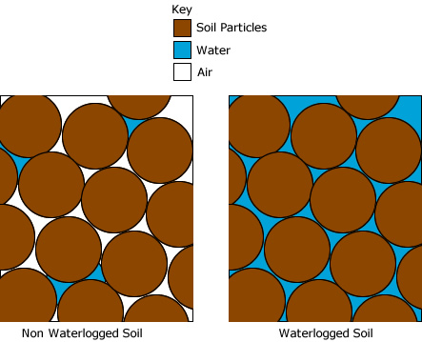

Figure - Differences between waterlogged and non-waterlogged soil

Further study into the topic, by Wright et al. (2017) comparing how planting a monoculture (single plant species) and a mixture of species in a flooded plot affect the impact of the flooding. Their research shows that while crops as a whole generally do not respond well to periods of flooding, certain crops respond better while in the presence of other plants whose presence mitigate the effects. No firm conclusion was reached regarding the cause of this but suggestions were put forward that the interactions between the plants, whether that be competitive or facilitative, were affecting the structure of the soil or otherwise creating a beneficial environment. While further research is needed, this is of interest as it shows that there are steps a farmer can take to minimise loss.

### Humidity

While environmental humidity is perhaps not one of the most obvious factors in the wellbeing of a plant, anyone who has visited one of the many botanical gardens worldwide will remember the hot, humid environment within the tropical greenhouses and the dry, hot environment supporting desert plants such as cacti. These greenhouses may share the same temperature range but the differences in humidity between each are enough to have negative effects should any of the plants be moved. For crops from tropical regions, especially those accustomed to rainforest conditions, very high humidity is required while those from desert climates require very little humidity to survive. Tibbets (1979) further argues that humidity has a noticeable effect on plants and this occurs mainly through transpiration and stomatal regulation. Transpiration is the process whereby water evaporates from the leaf due to a difference in vapour pressure between the leaf and the surrounding air and is proportional to changes in humidity. Stoma are essentially the plant equivalent of pores that open and close to allow the exchange of carbon dioxide, water vapour and oxygen. This action varies greatly between species, with some species not having stoma at all and these non-stomatic plants the correlation between vapour pressure and transpirational water loss was greatest. Plants with stoma were able to close these as the change in vapour pressure reached a critical point and thereby reduce the rate of water loss from the plant. This work shows that humidity has a provable effect on water loss in plants and is worth considering for inclusion in the list of features.

### Air Pressure

Air pressure does affect plants as proven by work carried out by Daunicht and Brinkjan (1996), however, this work was carried out in a barometric chamber at sea level and the results must be interpreted to be useful. In their tests, plants were grown at 100KPa, which is approximately sea level, and at 40KPa, which would equate to a position slightly lower than the summit of Mount Everest. The work shows that the lower pressure plant was stunted in growth, despite having the same oxygen and carbon dioxide concentration in both tanks. At the lower pressure, greater transpiration occurred and the rate of photosynthesis was approximately 12% less, showing the reason for the stunting. While this is useful information, it is not entirely useful for this project as the experiment was carried out in a laboratory. Should a farmer decide to set up a farm in a low-pressure area of the earth, there would be corresponding changes in temperature and wind speed at the higher altitude that would have a far greater and more immediate effect on their crops than the corresponding growth stunting. Therefore the effect of air pressure is of secondary concern.

It is important to consider air pressure measurement in the project for other reasons, mainly the correlation between this and other weather effects. Information from the Meteorological Office (2021a) shows that air pressure is linked to temperature changes, with hot air rising away from the surface and causing areas of low pressure to be left behind, and with cooling air sinking and causing areas of higher pressure at the surface. These pockets of high and low pressure have a very strong effect on the localised weather in the area and are key to forecasts. In general high-pressure results from sinking cold air which reduces cloud cover, resulting in gentler winds, less rainfall and periods of more settled weather. In contrast, high pressure results in water vapour being carried upwards, resulting in greater cloud cover and increased wind and generally more unsettled weather conditions.

### Pests

The effect of weather on pests should also be considered as this will potentially have a huge impact on crops. Since insects are all cold-blooded, they will generally be in a dormant state over the winter due to the lower temperatures and will only emerge from that state when temperatures rise enough to kickstart their metabolism. A study carried out by Schneider, Comte and Rebetez (2021) shows the effect of rising global temperatures due to climate change on common pests in Switzerland. This shows that various pests have a minimum temperature at which they emerge from dormancy and begin eating the plants or trees they habitually eat. With rising temperatures and less harsh winters, this process is gradually making winter conditions more favourable for the pests and is causing more insects to survive over winter leading to greater numbers. Concern was also expressed that the milder winters might encourage the migration of pests who typically could not survive the winter in Switzerland, leading to a whole new set of pests entering the area and damaging plants and trees. This encroachment and earlier emergence from dormancy a direct threat to agriculture and continued monitoring of the weather, year upon year coupled with some knowledge of crop-specific pests would be of interest to farmers. This reinforces the need for weather monitoring for farmers, albeit from a different perspective.

## Climate Change

Climate change has become a frequently discussed topic over the last few decades and the general public are very aware of the core message that industry is causing the planet to gradually warm-up, resulting in warmer winters and hotter summers. This is common knowledge at this point and will not be discussed in great detail of itself, however, it is important to understand these changes from the point of view of the farmer since these changes will have a direct effect on the lifecycle of their crops. This topic is far-reaching and diverse since the crops grown worldwide are also diverse and directly affect the ability to feed the population of all countries worldwide. Since the population of the planet is increasing steadily, the importance of farming to produce enough food

Hatfield et al. (2020) discuss these factors, including references to the previously discussed topic of pests, and show how various studies into this topic have shown the effect of climate change on crops. For example, Tack et al. (see Hatfield et al. 2020) show that wheat production in Kansas in the USA has dropped by 40% due to an increase of 4°C and there is evidence that modern varieties of wheat are much more susceptible to heat stress once the temperature goes above 34°C. Similar results were provided for corn, maize, rice and soybean showing a decrease in yield per degree increase. This is a worrying trend for farmers whose family and livelihood depends on the yield of their crop.

## Communication methods

Communication methods between the weather sensor and the server must be considered since the sensor can be assumed to be placed in a relatively remote location without the communications backbone which is more readily available in urban areas. There is also a great deal of discrepancy in terms of the percentage of the population in each country who can access the internet and this will have a great deal of impact upon the project moving forward. Unfortunately, the hardest hit in this respect will be the poorer farmers that it was the intention to target and this creates a difficult problem.

### WiFi (Wireless Fidelity / Wireless Local Area Network)

According to data released by the International Telecommunication Union (2020), there simply is not enough uptake of home broadband in developing countries to give this method of communication much credence. In more developed countries, this may be a good option but it would also require a source of power, a WiFi signal to be present at the field and a broadband subscription so, logically, this method seems to be too costly overall.

### Mobile Data (GSM/LTE)

In terms of general internet access, according to data released by the International Telecommunication Union (2020) Africa is the continent with the worst overall access to any form of the internet with 23% of the population being without mobile internet and only 28% of the population having internet at their home in urban areas, dropping to 6% in rural areas. While this varies from country to country within Africa, the discrepancy is very high, creating a very large technological divide. For example, in the Republic of the Congo, only 9% of the population are users of the internet in any form and only 1% have internet access at home. Meanwhile in the more relatively prosperous countries such as South Africa where 56% of the population uses the internet and 62% have the internet at home. In the remainder of the world, internet and mobile availability are generally better however countries such as Uzbekistan, Turkmenistan, Nepal, Indonesia and Malaysia are still fairly low with less than 30% of the population using the internet. However, the figures suggest alternate reasons for the sometimes low internet usage, for example, Uzbekistan has mobile phone ownership rates of 68% but the report shows that while 22% have basic technology skills, 5% have standard skills and the number with advanced skills is low enough not to register as a statistic. In almost every country, however, mobile ownership is higher than computer ownership which suggests that the connectivity method should make use of this fact and use mobile data.

It should be noted that there are various things to consider in terms of mobile data since this depends on different carrier frequencies for 2G (GSM), 3G (LTE) and so on. Each of these requires specialised receiver chips and so there is no solution currently which allows a device to access all existing bandwidths. The pricing for these increases sharply with each increase in speed and a chip that uses 2G would cost approximately £3.50, while a 3G version would cost over £50 and a 4G chip would cost upwards of £60. The faster chips would not bring any additional benefit to this project since they will be posting a small amount of data to a web server. The higher prices for these chips are far outside the budget envisioned and so only the 2G chip is really useful to include however, a project with a higher budget could quite easily adapt this project to include either of these since the changes to the board and the code needed to include the upgraded version would be minimal.

Care should be taken when choosing a mobile network to work with since there has been a lot of recent activity by carriers to sunset (close down) older networks such as 2G and 3G meaning that there may no longer be any signal available in some countries. Worth (2020) discusses the proposed closure dates for various countries, giving an overview of this globally. At the time of writing, 2G has been shut down in the USA, Canada and several East Asian countries such as Japan and Taiwan and 3G has also been shut down in several countries worldwide. It should be noted that the countries performing shutdown tend to be the more technologically advanced countries and this sunsetting is part of the process of switching to 5G. This is also very dependant on the provider, for example, Vodafone is sunsetting 3G and retaining 2G as a fallback service, so even within a country, provision may be different from provider to provider. Despite this sunsetting, the provision in developing countries is still good enough to keep 2G as a possible solution however care should be taken should this project be repeated as this is likely to change within the next 5 years and so current research will be required.

### Radio Frequency Communication

Radio communication could be considered for transmission of up to 100m using radio waves, however, this type of communication would need to be between a transceiver and a receiver unit which would require a second unit. According to information on Last Minute Engineers (2020), this method is good for short-range communication from multiple devices to a central unit which would have an internet connection and so would be great for certain situations, it is also very low cost requiring a single internet connection and some fairly cheap components which cost less than £2. Communication in this manner can either be simplex (one way) or duplex (two way) making this option fairly configurable, however, this would only be of benefit in situations where the weather sensors can relay to a central unit and where multiple weather stations would be required, which discounts it for use in the particular demographic being targeted.

### LoRa (Long Range WiFi)

The LoRa Alliance (2021) has information showing that LoRaWAN is fast becoming the default way for IoT devices to communicate, using low power, long-range signal to connect to a gateway device which can then transmit data to the internet. This technology was specifically developed for large-scale IoT based solutions like sensor networks or GPS tracking on a fleetwide scale and is the core communication method for many of the higher-end sensors on the market. like RF transmitters, this uses radio waves to transmit data and while in a city, this can be a distance of up to 5Km, due to interference from the surroundings but in rural areas, this can be up to 16Km. Many community gateways are being set up which can be accessed for free making this a great solution on a budget but this depends greatly on the local presence of a gateway. Setting up a gateway would be the most ideal way of implementing this technology, however, this is relatively expensive and Arduino Uno units including the LoRa standard can cost over £200 making them unsuitable for this project. The free versions of this technology would be usable in this project but the coverage in developing countries is very poor currently and the standard would require a different chipset for different continents since each continent has a preset frequency at which LoRa is legally allowed to operate. These issues make the technology unsuitable for this project but due to the rapid uptake of this technology, this may change in future years.

## Market Research

Market research was carried out to understand the current market for weather sensors and help place this project in terms of price. For completeness, the research was carried out to find both commercially available weather sensor solutions and includes “do it yourself” type kits which are available cheaply and readily on sites such as Amazon, eBay, Ali Express and Banggood.

### Commercial Weather Sensors

Commercial weather sensors/weather stations range from single-unit weather stations for home use right through to bespoke solutions used in large scale, commercial agriculture. There are many companies in this market and prices start at around £60 for basic units and can reach several thousand pounds for the bespoke solutions. Many companies at the higher end of the scale do not advertise prices openly and their websites request customers contact them for a quote so the following research is based on those with prices available for comparison.

#### allMATEO Weather Stations

According to the price table on the allMATEO (2018) website, their solutions start at €999 (approx. £856 as of 20/08/2021) rising to €1999 (approx. £1714). This is a rather large jump from other solutions and shows a rather large gap between commercial and consumer systems. The feature list varies slightly from other solutions and of course, the more expensive solutions offer a wider range of features and communication methods. Their basic system offers the following weather sensors:

* Temperature
* Humidity
* Air Pressure
* Solar Intensity
* Rain Amount
* Rain Intensity
* Frost Warning
* Wind Speed
* Wind Direction
* Soil Moisture
* Soil Temperature
* Leaf Wetness

As expected the list of features is greater and this system seems to be able to not only check the ambient conditions but also provides feedback from sensors buried in the ground beside the crop. This is an interesting set of additional sensor readings however the price is certainly orders of magnitude above the income of the audience selected for this project and this solution would be out of their reach.

##### ProData Weather Stations

ProData Weather Systems (2015) is a UK company that specialises in automatic weather sensors and according to their website, their products range from £350 to £1500 which is certainly a little cheaper than allMATEO at the bottom end but is still a fairly sizeable investment. Taking their Davis Vantage Vue 6250UK device as the cheapest available for comparison, this device boasts the following sensor readings:

* Wind Speed
* Wind Direction
* Temperature
* Humidity
* Air Pressure
* Rainfall
* Additional derived readings such as Wind Chill, Dew Point

As with the allMATEO brand, this list doesn’t seem to include any additional features that couldn’t be implemented in a prototype weather station.

### Kit Based Weather Sensors

Kit based weather sensors are generally available on any of the main reseller websites such as Amazon, eBay, AliExpress and BangGood and resellers on these sites tend to have wildly differing opinions on the value of their merchandise, with some prices being vastly overinflated. In the following product details, any prices which were inflated in this manner were disregarded and an average price range was used which represents the more common price a buyer could easily find. It should be noted that a Raspberry Pi unit is essentially a microcomputer and capable of running an entire operating system so using one for a basic task such as this is very much overkill. While it would be possible to swap the microcontroller in these kits for a Raspberry Pi Zero for £5, at the time of writing, no weather station kits based around the Raspberry Pi or Pi Zero were available for inclusion in this comparison.

#### IdeaSpark Weather Station kit

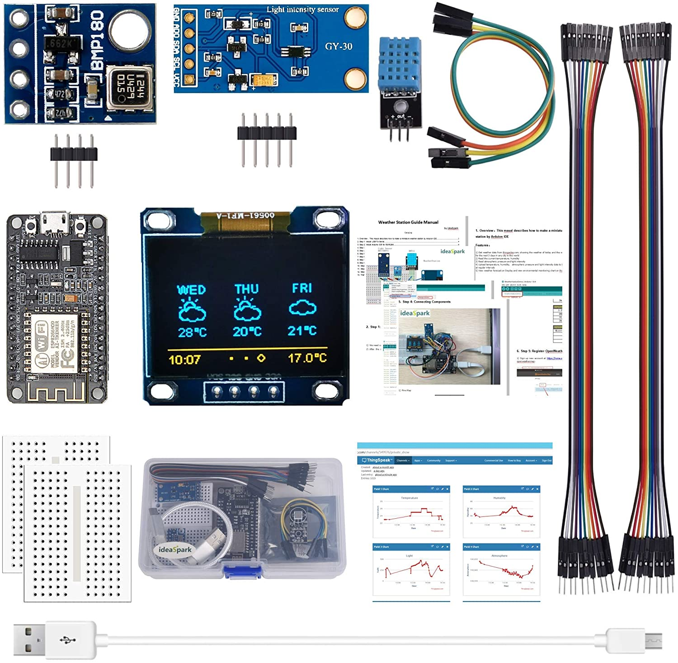

Figure - IdeaSpark Weather Station Kit

* **Price: £8.99 to £15**
* **Communication: WiFi**
* **Contents:**
  + ESP8266-12E - Microcontroller Board
  + DHT11 - Temperature and Humidity Sensor
  + BMP180 - Atmospheric Pressure Sensor
  + BH1750FVI - Light Sensor
  + OLED Display - Screen
  + USB cable - Power and Programming
  + breadboard
  + DuPont cables

IdeaSpark is a trading name of the Shenzhen Guangjiang Technology Co., Ltd. which is a Chinese electronics company selling a wide range of electrical devices and handheld sensors. The IdeaSpark Weather Station Kit represents the vast majority of listings and is repackaged and resold by many other sellers on the main reseller websites. The kit is very good value, even at the higher end of the price range and would have been a great basis for this project. However, there are several issues with this kit that make it unsuitable for the type of installation required. The pack does not contain any way of powering the completed weather station apart from the provided USB cable, which makes this kit unsuitable for use remotely, where a suitable power source would not normally be available. This could be remedied by adding the various battery and solar power components but it is important to understand that the breadboard and wires supplied would not be sufficient for this and so some parts of the kit would also need to be replaced. It does not come with suitable housing and so some housing would need to be sourced. The weather conditions monitored by this kit are only part of the range of conditions that are useful so additional sensors may need to be purchased and installed. Perhaps the most unsuitable feature is the use of the ESP8266, which is a board that contains both a microcontroller and WiFi chip on the same board. As discussed in the communication section previously, WiFi is simply not widespread in developing countries, especially the rural parts where the sensor is likely to be deployed.

#### SparkFun micro:climate kit for micro:bit

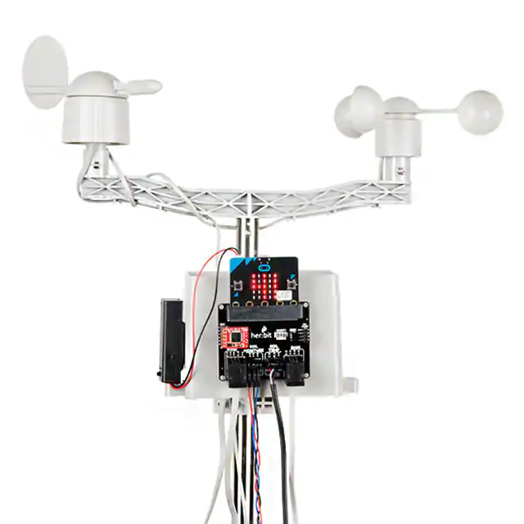

Figure - SparkFun micro:climate

* **Price – approximately £88.99 or £105.99 with the micro:bit**
* **Communication – None**
* **Contents:**
  + SparkFun weather:bit - Main Board
  + Weather Meter Kit - Wind Vane, Anemometer, Rain Guage
  + SparkFun Soil Moisture Sensor
  + SparkFun OpenLog - Data Logging Board
  + Waterproof Temperature Sensor
  + micro:bit Battery Holder - Batteries not included
  + Pocket Screwdriver Set
  + Jumper Wire

SparkFun is a well-known brand that manufactures component boards for Arduino and Raspberry Pi as well as creating kits for various projects. This kit contains some relatively high-end instruments in the form of the anemometer, wind vane and rain gauge. Research into commercial anemometers placed the cost of these at anything from £40 upwards and the rain gauge is a “tipping bucket” type which costs between £13 and £21 and has a pair of buckets internally which fill and empty in a similar motion to a see-saw and accurately measure the volume of rain. While the weather components in this kit are good and would work with any microcontroller, the microcontroller board the kit is designed for is the BBC micro:bit which is mainly used for educational projects and is essentially designed for use by children. This isn’t ideal as the boards are limited in scope and lack more advanced configuring options. In terms of pricing, the kit does not include the micro:bit board so one must be bought separately as well as some batteries, this and the lack of communication tag make this kit very much out of reach of the budget for this project.



New Ideas

Introduction

The research carried out in Chapter Two raised a broad range of weather conditions that could be monitored, showed the many communications methods and also briefly discussed the options for the hardware. With this wide array of options available, this chapter will aim to focus these options to give direction to the project and to allow for a concrete set of requirements to be created and this will directly influence the design and development of the weather station in later chapters.

Before commencing work, it is essential to maintain a plan for the development of the system. With this project changing midway through the year, the original documentation and Gantt chart relate to the original project and so a new plan and Gantt chart were drawn up and are available in APPENDIX 1 to view. As mentioned previously, the developer User Requirements.

## Feasibility of the Project.

From the research carried out in Chapter 2, it is possible to justify the project in terms of costs and to make some informed decisions about the hardware to incorporate into the project.

### Financial Feasibility

The market is divided into two halves with a very broad distinction between those halves and a clear gap in the market between the disparate price points. On one hand, there are very expensive solutions that are custom-built for big agriculture businesses and are used to micromanage climates in fields and greenhouses to maximise production. These solutions often resort to the use of custom made units and due to the high price point can offer highly novel solutions such as internal wifi hotspots which can not only connect to the internet but can allow nearby devices to connect also. On the other hand, there are some fairly cheap kits available that are certainly affordable but offer minimal functionality and are generally intended to be used by hobbyists in the development of sensor-based displays to connect to home wifi or simply to display the current temperature on a screen. This gap starts at around the £20 mark and continues to around £89 where some smaller DIY units can be purchased with the professional units start around £600 giving quite a large potential range for a price point, however, it should be remembered that the intended audience does not have a large amount of disposable income and will often be consuming their crops themselves and so by pricing the components too high, the weather sensor would become too expensive.

It is an uncomfortable but realistic conclusion that the weather station cannot possibly be made cheaply enough so that every farmer can afford it. However, the initial costings do show that a weather station with a fairly comprehensive set of features could be developed for under £60 and this is based upon cost for single components which will not factor in any economies of scale in terms of bulk purchasing. As such, this price was chosen as a realistic top end for the project and the final costing should attempt to use this as such. If the project can come under this budget then it can be considered successful from a costing point of view since this price will naturally decrease if the components are bought in large quantities. There are also several options for offsetting the cost to some degree, including co-operatives where companies like Nescafe run their network of farms and farmers can be provided with help and advice in return for fairer prices and the promise of selling their product directly to the manufacturer. Initiatives such as this could be approached to potentially include access to a weather station as part of the deal, with the cost absorbed initially by the company itself and spread into affordable payments across the duration of the contract. This model of encouraging individual farmers to work together in communities is prevalent and is one of the leading approaches taken by charities as well.

### Hardware and Software Choices.

#### Sensors

The research carried out highlights the need for all of the highlighted weather readings and this is backed up by the presence of sensors capable of measuring these weather conditions in the competitor products. This very clearly points to a need for these to be included both from the commercial viability side of things and to ensure that any expansion of the project in future into the area of analysing and predicting weather will have all of the core information readily available. While this is beyond the scope of this particular project, it is a very logical next step and would undoubtedly add to the usefulness of the weather sensor. As such, the following sensors will be included in the project:

* Temperature Sensor
* Air Pressure Sensor
* Rainfall Sensor
* Humidity Sensor
* Windspeed Sensor

In addition to these, two measurements cannot reasonably be included simply due to the price of the sensors, which is unfortunate. These are a rainfall measurement sensor that would measure the amount of rainfall (in millimetres) and a wind vane that would record the direction of the wind. Both of these devices are orders of magnitude more expensive than the other sensors and are greater than the cost of the entire project. For this reason alone they will be omitted, but both should be considered anew by anyone following this project in future years.

#### Microcontroller

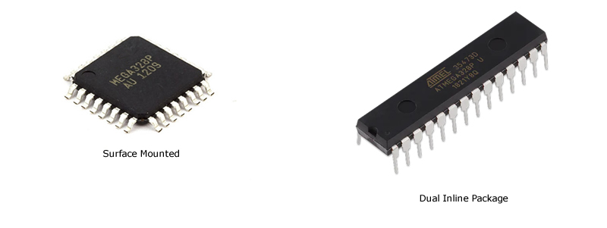

Figure - Surface Mounted versus Dual Inline Package

In terms of microcontrollers, there are two form factors of the actual physical chip which must be considered, a comparison can be seen in Figure 4. One of these is a Surface Mounted, smaller form factor which would require a printed circuit board and a great deal of expertise in soldering microelectronics to attach it to the circuit due to the very compact nature of the solder pins. The other form factor is a Dual In-Line Package (DIP) version which is compatible with the existing hole spacing on breadboards, where the solder connections are a few millimetres apart. Choosing this form factor will require less in terms of soldering skills and the use of breadboard will allow for faster creation of prototypes rather than having to create and order printed circuit boards for each prototype.

In terms of the model, There were four considerations – memory, power consumption, available documentation and price. The Arduino Uno with an Atmega328P MCU chip came out on top in terms of available documentation, power consumption and price however, at 2048 bytes of memory, this is quite a constrained system. More powerful MCU’s are available but these are much more expensive and with cost factoring into this project it was decided to investigate whether the Atmega328P could handle the desired application.

#### Software

In terms of the MCU, C++ is the standard language for programming Arduino and so this is the only option available. As such, C++ will be used on the device.

For the web server, PHP and MySQL were selected due to an existing server with these languages being available, however, the web is very flexible and the language and database used on the API can easily be changed should any reader wish to recreate the project.

## Potential Issues

This project involves two key areas, the first and most likely to cause issues is the creation of a physical weather station which will involve the use of microcontrollers, sensors and the use of some communication modules acting as a modem. This raises several issues as the project was chosen based on interest rather than being based upon a body of prior knowledge and so this necessitates some extra research and could potentially result in pitfalls and mistakes being made. This project should be viewed from the perspective of an amateur in electronics learning and developing skills from the ground up rather than having a wealth of background knowledge already in place. This fact will have a very strong impact upon the project, timescales and the development process moving forward. It is possible, even at this stage, to foresee several areas where issues may occur and it is also probable that what seem like reasonable steps to someone without experience may be obvious errors to a more seasoned microelectronics user and may lead to a dead end. Should this occur, it will become necessary to backtrack and rectify any issues which will further affect timescales. The following main areas are of concern and a discussion of the potential within each area follows.

### Power

There are several obvious concerns regarding power, with the weather station’s intended use being in remote areas. This being the case, there will not be a suitable power supply available on-site and so batteries will need to be used to power the device. Without resorting to the use of something like a car battery which would offer a very large life, the system will most likely have to use Lithium Polymer or Lithium-Ion batteries. These battery types are widely used commercially where lithium polymer batteries, which generally have a thin, flat, rectangular form factor are used in mobile phones and 18650 lithium-Ion batteries, which are cylindrical and can be connected to form larger power packs are commonly used in laptops. The biggest concern with these types of batteries stems from both of these being notoriously badly behaved if they are drained too much or charged too much. This under-voltage and over-voltage of the cells can often cause catastrophic failure where the contents react to create a gas that puffs the cell up and once the contents mix with oxygen in the air, they burn readily causing the batteries to burst into flame. Specialised circuitry is used in commercial devices to essentially cut the battery off should under or overvoltage occur and it’s not certain how readily available these may be. These batteries are also very ready to discharge and will do so readily if the contacts are bridged by anything which can carry a charge meaning that extreme care must be taken to ensure any connectors used are insulated when not in use.

Aside from the somewhat frightening fire risk, there are some questions regarding the actual performance of the batteries. These cells generally have a safe operating voltage of between 2.8V fully depleted and 4.2 volts fully charged which is different to the voltages used by most microelectronics. Generally, these operate at 3.3V or 5V and so there is some concern about the ability to convert between these. It is also unknown at this time how power-hungry each sensor is and whether it is even possible to run several of these at the same time meaning that the list of sensors proposed in this chapter may not be possible. These potential issues must be factored into the project plan and so should be considered at this point. The selected plan for the project will need to be very flexible and any hardware or software developed will undoubtedly have many iterations as more is learned and pitfalls discovered. This project will therefore include an investigation of whether the selected feature set can be successfully used on the chosen hardware.

## Safe Operating Temperatures

As with all electronics, there is a safe working temperature range for the used in the project and this must be taken into account in the same way the temperature of a processor must be monitored. This range seems to be standard for microelectronics and is between -40 degrees Celsius and 85 degrees Celsius. This range must be adhered to to ensure that the circuitry continues to function and since it must be inside an enclosure to protect it from the elements, the temperature inside such a unit in direct sunshine could present a problem.

### General Electronics

Due to the lack of electronics experience, it will be necessary to learn all of the basic components such as capacitors, resistors and diodes and this may be a difficult task and may affect development time adversely. Initially, this may not be an issue as most components seem to have wiring diagrams available which highlight if these additional components are required and how to include these in circuits. However, this is relying on third party information and should this not work for any reason, more research will be needed to allow the correct decisions to be made in terms of chances to the prototype.

### Microcontrollers

In general, Microcontroller Units (MCU) are compact integrated chips that function as a miniature computers and are used to control features of larger systems. Typically, these units contain a processor, several types of memory and the ability to control Input and Output, allowing them to effectively control other systems and peripherals. According to Adafruit (2021) who manufacture peripherals for these units, MCU’s are based upon Harvard Architecture, while standard computers are based upon the Von Neumann Architecture and this difference in implementation is important to consider with regards to this project. With the Harvard Architecture, there are effectively two main types of memory required, a non-volatile flash memory which is used to store the executable program which is run by the unit and an amount of Static Random Access Memory (SRAM) which is used to store things like developer created variables and objects used by the program in the randomly accessed Heap and also the compiler controlled Stack which is a contiguous block of memory and contains local variables, function information and parameters. While the Stack remains very efficient, with information being added and removed effectively, the Heap can cause issues as it can become fragmented. Fragmentation can mean that the Stack and Heap eventually overlap and this can cause the program to terminate abnormally.

In terms of potential issues, the combination of Heap and Stack on the same, very small piece of memory has the potential to cause issues with fragmentation and the overriding of other variables should any structure increase dynamically and overwrite memory locations already in use. This is exacerbated by the relatively small amount of memory available on an MCU which is typically measured in kilobytes.

## Methodology

With so much about electronics and the individual sensors unknown at the start of this project, creating a very detailed plan is not realistic for the early sprints and so, the decision was made to use Agile as the project methodology. This methodology allows for the project to adapt as it progresses and works well in a project where the requirements are likely to change. In addition, a more hardware-focused methodology was adopted to allow for the same flexibility on the hardware side. This methodology, called Evolutionary Prototyping, focuses heavily on initially creating basic prototypes which can be tested and which function as a way to learn about the system and to test different implementations and configurations without having to know the details of the overall system. This process allows the developer to focus on existing knowledge and gradually expand that knowledge through a process of creating and testing evolving prototypes. The early prototypes will be fairly naïve and will undoubtedly change rapidly as testing identifies faults and issues however this allows the developer to build upon their current knowledge and to improve or evolve with the prototype. This knowledge is then used to improve the hardware, iteratively refining and fixing issues based upon gained knowledge.

The combination of Agile on the software side, Evolutionary Prototyping on the hardware side and the use of Test-Driven Development provide a complementary set of practices that are known to work well with unfamiliar development. By having methodologies that can respond quickly to change and by using testing to confirm each step, it is possible to have a greater amount of faith in existing work and it allows for small steps to be taken confidently into unfamiliar territories. This security and the use of an iterative approach seems to offer the most practical path moving forward.

Initially, a relatively general set of requirements will be created to give direction and the project will allocate a period where a process of experimentation with the various sensors and MCU’s will happen, testing how they work, how they interact between each other and testing individual features to eventually combine this into a complete system. With this in mind, the following steps will be followed:

1. Each component will be connected in isolation to an Arduino Uno board with Dupont Cables which are not reliant on soldering and mean that small, testable prototypes can be created in minutes.
2. These will be tested in isolation using Test Driven Development practices where tests are written before software and software is only written to allow a failing test to pass.
3. As these tests are carried out, a corresponding suite of tests and code snippets will be covering the basic functionality of the devices.
4. Once a complete set of snippets is available, these will be incorporated into classes, making use of member functions to contain and refine these snippets, forming the core functionality of the final software.
5. As the prototype evolves, this software will evolve in tandem and eventually a minimum viable product will be available.

Once these stages have been completed, the knowledge gained will be used to create a more permanent, more final prototype circuit where the components are introduced gradually to the board and wiring will be soldered to a Veroboard. This is a type of breadboard with copper lanes on the back to allow for the creation of power and data channels and this will create a more permanent, robust prototype. This prototype will allow for the next sprint of testing to begin and for integration tests to be carried out as each component is added to the circuit board. These tests will help in identifying any potential issues concerning communication between components and will also identify any problem areas of the circuit where perhaps power issues are happening. Once the components are all on the board and working together well, and testing has been completed, this prototype will become the minimum viable product and at this stage, there should only be minor changes necessary.

## Requirements

In a typical software development project, gathering user requirements is an important early step and by setting out what the end-user expects, an understanding of the direction development must take is gained and when these requirements are successfully met, the development process can be considered complete. However, due to the nature of the supposed end user in this project, this particular step cannot be easily achieved as it will not be possible to find and contact farmers in developing countries to carry out a questionnaire or interview. In place of this step, it will be sufficient to use the research carried out in Chapter 2 to come up with a set of features and by comparing these to existing solutions a good set of features can be created. It is also worth mentioning that there are likely to be variances between farmers in terms of the features they need and value and so the final product resulting from this project can be seen as more of a suggested road map testing the feasibility of a fully-featured solution. The modularity of the sensors and components lends itself well to allowing Individual farmers a large degree of flexibility and they may for example not be able to afford the cost of using a particular mode of communication and may choose one of the alternatives.

To create a concrete foundation for the project the following requirements have been created. These represent the broadest basis for both investigating the possibilities within the bounds of the project and ensuring that the final designs are relevant to the many farmers and diverse climates and crops that the project may be used with.

* The final prototype shall aim to include sensors that can detect the following:
  + Temperature
  + Humidity
  + Air Pressure
  + Presence of Rain
  + Wind Speed
* In addition to the above, the internal temperature of the device will be recorded to ensure the device itself remains within safe operating range.
* An enclosure must be chosen to house the circuitry and this will protect it from the elements.
* The prototype will take measurements at regular intervals.
* The system should perform error checks on the received data, ensuring that communication is happening, that data gathered from the sensors are actually within the tolerances of the individual devices and that the process is as reliable as possible.
* These measurements will be transmitted via HTTP protocols to an online API with a MySQL backend database.
* The process, in terms of the weather sensor itself, will be automated and will not need any interaction from the user.
* The user should be able to view the data from the weather station via a web-based interface.

## Automated Process Flow Chart

To help visualise the automated steps, the following flow chart was created, see Figure 5. This flow chart demonstrates visually the steps taken by the weather sensor and web server in the timed process which will be carried out by the final prototype.

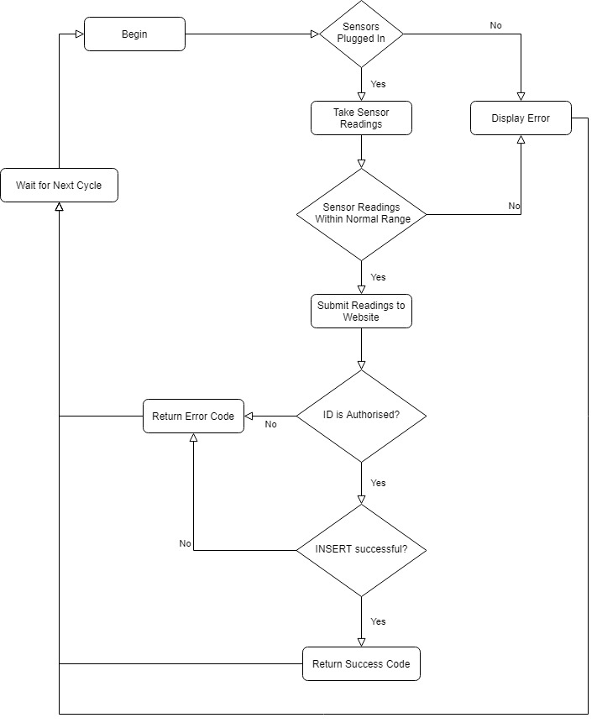

Figure - Process Flow Chart



IMPLEMENTATION or INVESTIGATION

Introduction

This chapter will focus on the creation of the weather sensor hardware and supporting software and this process will be split into three phases or sprints :

* Sprint 1 will focus on minimal prototypes for each sensor and the creation of minimal tests and software, including any third party libraries needed for the sensor to function at a basic level. This sprint will also include the basic database and API functionality.
* Sprint 2 will build upon the information, software and test suite created in sprint 1 and will progress to the creation of a Veroboard prototype weather station which then can be used for integration testing and the creation of software classes.
* Sprint 3 will again build upon sprint 2 and will be a final opportunity to address any issues that have arisen as part of sprint 2 in an attempt to finalise the hardware and software and gain results.

The development process is one with a lot of unknowns and so the methodology for both software and hardware reflects the need for well planned, small, iterative steps with robust testing. This process should help minimise backtracking due to any issues that may occur and should help to keep the project progressing.

In terms of development, C++ was used as the native language for Arduino and the Arduino IDE was also used, however, for the creation of classes, the Microsoft Visual Studio Code IDE was used simply because of the more advanced syntax highlighting and autocomplete functionality which is lacking in the Arduino IDE.

## Important Electronics Terminology

Before progressing to the actual sprints, it will be useful to explain some of the terminology and basic phrases used throughout these sprints. Development on Arduino requires an understanding of power and communication channels and pins and these main concepts are discussed in the following sections:

### Voltage Common Collector (VCC) and Ground (GND)

These acronyms are short for Voltage Common Collector and Ground. VCC is one of many acronyms which for this project all refer to the positive connection of the given power source. The variations of this are important in electronics as some can identify that current must flow in reverse, however, all of the components in this project behave in the same way and so VCC can simply be thought of as being connected to the positive terminal of the battery. In this project, GND will simply refer to the opposite terminal of the battery, the negative terminal.

### Receive (RX) and Transmit (TX)

For Arduino projects, serial communication is one of the main forms of communication with components where individual bits of binary data are transmitted digitally via the use of a HIGH (1) or LOW (0) signal on the connecting wires to represent binary ones and zeroes. This type of communication is not readily understandable by humans and requires a serial communication library. This project will use the standard library that ships with the Arduino called SoftwareSerial. For this to work, most components that use serial communication have 2 dedicated terminals, one for Transmit (TX) and one for Receive (RX). These terminals are used to send information from the component and to receive information from other devices accordingly. Any device connected to the component in question must have the TX and RX terminals reversed so that TX on the source component is connected to RX on the recipient and vice versa. These can be thought of in terms of a telephone call – when one party talks (TX) the other party must listen (RX).

### I2C Communication

One of the other main for of communication is a protocol called Inter-Integrated Circuit Bus (I2C, IIC or I2C). This protocol is another form of serial communication between master and slave devices and uses a Serial Clock pin (SCL) and a Serial Data pin (SDA). This protocol functions slightly differently in that the serial clock is used to synchronise data transfer between devices and the serial data pin is used for the actual serial communication. This protocol allows many individual components, which must all use the I2C protocol, to communicate on a single bus and so can be a great space saver on circuits. For this project, only the BME280 sensor is capable of using I2C communication and so it is sufficient to think of this as an alternate, quicker version of serial communication.

## Sprint 1

This sprint is very much an exploratory and fact-finding sprint that aims to lay down the foundation for all future work. In this sprint, the core mechanics of each component will be explored with the help of minimal prototypes and minimal code will be produced to access and utilise the required functionality. The following parts were selected for use in this sprint:

* Arduino Uno
* BME280 Temperature, Humidity & Pressure Sensor (internal Temperature)
* DS18B20 1-Wire Digital Temperature Sensor (External Temperature)
* SIM800L GSM Module
* NEO 6M GPS Module.

### Prototypes

Prototypes were created for all of the individual components within the project, starting with the BME280 integrated temperature, humidity and air pressure module. This module has 4 terminals, VCC, GND, SCL and SDA and when connected to the Arduino Uno in the following way, the prototype is complete.

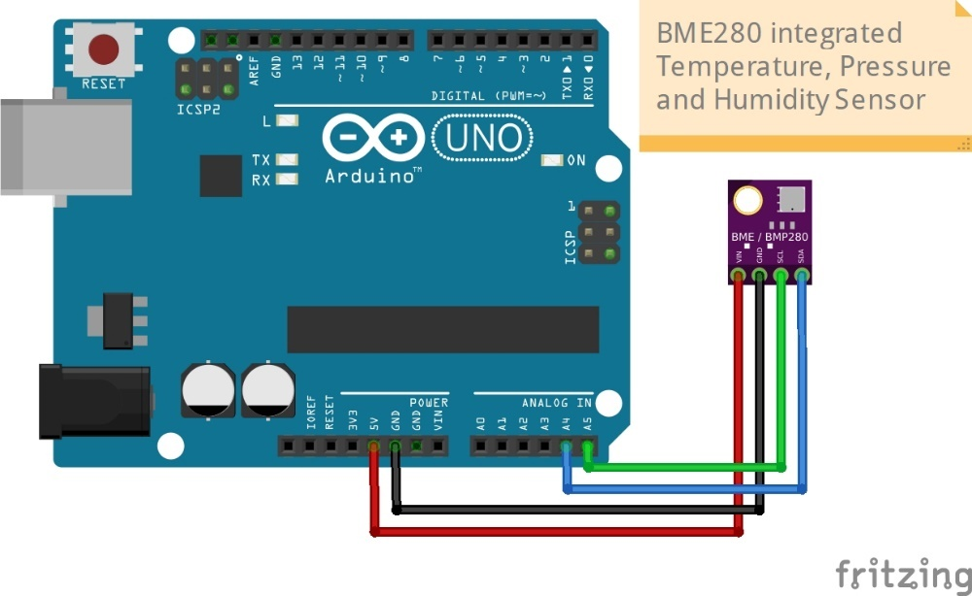

Figure - A BME280 sensor connected to an Arduino Uno

For the sake of brevity and to avoid needless repetition, only the process for the BME280 will be discussed in detail however, the diagrams for the other components can be found in Appendix 2 and all other components went through the same process during this sprint.

The datasheet for the component was first found (Bosch., n.d.) and this was used to identify the type of communication used and the required voltage. This is an important step as too high a voltage can destroy the electronics upon the integrated circuit and render the component useless. Thankfully in this particular case, the circuitry on the BME280 is tolerant of 5V and so can be connected to the 5V channel of the Arduino, with the GND channel connecting to the GND channel on the Arduino. In terms of communication, the SCL and SDA channels on the Arduino Uno correspond to the A5 and A4 pins respectively. This was discovered by using a detailed pin mapping diagram created by A. Zait (2020) which very clearly shows the various functions of each pin.

Once these four wires were connected, the hardware prototype was complete and research was carried out to understand how to communicate with the device. There are several ways to do this, as the device supports communication via several protocols, however, the I2C protocol allowed the use of the A4 and A5 pins which would not be needed by any other device and so this freed up more pins for subsequent devices and so this protocol was selected. The research identified that there was a library, which is the name given to a class or accompanying code library for Arduino projects, available and that this library included a class that could be used to interface with the device and so a simple program was created to utilise this.

To make the code more understandable moving forward, the decision was made to name classes that interacted with a specific device after that device and so the class for the BME280 device would simply have that name. The first test created was based upon a feature of the library to check if the BME280 was present on the circuit and so a test to check if the device was present was written. This test, in true Test-Driven Development (TDD) style, would be based upon the final implementation and at this early stage, this would involve writing a test for code that did not exist and checking the validity of the tests themselves, a Unit Testing library would be required.

There are several libraries available for unit testing on Arduino however it became clear very early on that these libraries, while well written and thorough, simply used too much of the Uno’s precious SDRAM and it was upon discovery that the Arduino Unit library required a minimum of 25% of the SDRAM that the decision was made to simply use custom test functions. With serial communication being the main focus of the system, it was clear at this early stage that any tests would only have to deal with Boolean data types and strings of data and so basic comparison functions for these were written to be the main focus of testing.

It should also be mentioned that it wasn’t sure whether a fully implemented class was needed for this project or whether a simple library of functions would be sufficient. Arduino development, again because of the limitations on memory, often shies away from implementing classes due to the overhead incurred by the creation of such objects. In terms of TDD, the idea is to create tests that use the imagined final version of the code including function names and classes if required so, at this early part of the project, the decision was made to use functions and wait to see how the memory situation developed before making a decision.

## Software and Testing

Test-Driven Development (TDD) is a methodology for testing which follows an incremental loop whereby a test is written so that it fails, enough code is written to pass the test and the code is then refactored to include any refinement. This process began by writing a test to check if the BME280 was present, using the non-existent BME280_IsPresent function and checking that the return value for this was true. This failed as a test, allowing the creation of minimal code for the function which invoked the functionality within the required Arduino libraries. Eventually, this test passed and the refactored function code was complete.

The final stage of testing for this device was to test the readings from the sensor itself and this was accomplishes using a test for the non-existent function BME280_ReadSensor and this would simply ensure that a valid value of the type required was returned. This was backed up with visual output since the values would vary and this would allow for checking that the temperature sensor increased in value when touched by a finger for example.

With the very basic wiring and functionality working, this process was followed for all other components and these all worked fairly well, with a few minor changes in the library needed to replace outdated libraries. Once this set of tests and information was gathered, sprint 1 was essentially complete and sprint 2 could begin.

## Sprint 2

This sprint was where the really interesting elements would start to happen and where some of the more complex issues would surface but first, it was time to heat the soldering iron and create the first fully functional prototype for the weather station. Before starting, a basic database and basic API were created and tested, so that the backend would be able to accept input and store it once the prototype was finished. The database diagram created is shown in Figure 7

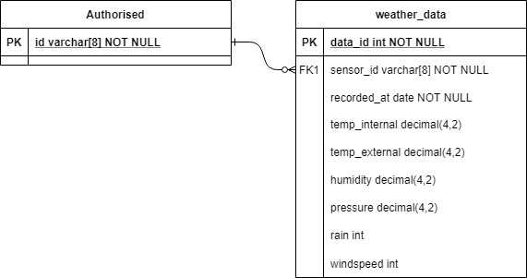

Figure - Database Diagram

There were some teething issues with this in researching the correct solar panel to use and finding the correct circuitry to protect the batteries from over-voltage and under-voltage but once solutions were found the following design (Figure 8) was drafted. The Fritzing software used is a vector-based application that allows for the planning of circuit boards without the need for a deep understanding of electronic schematics, making it ideal for visually planning a layout.

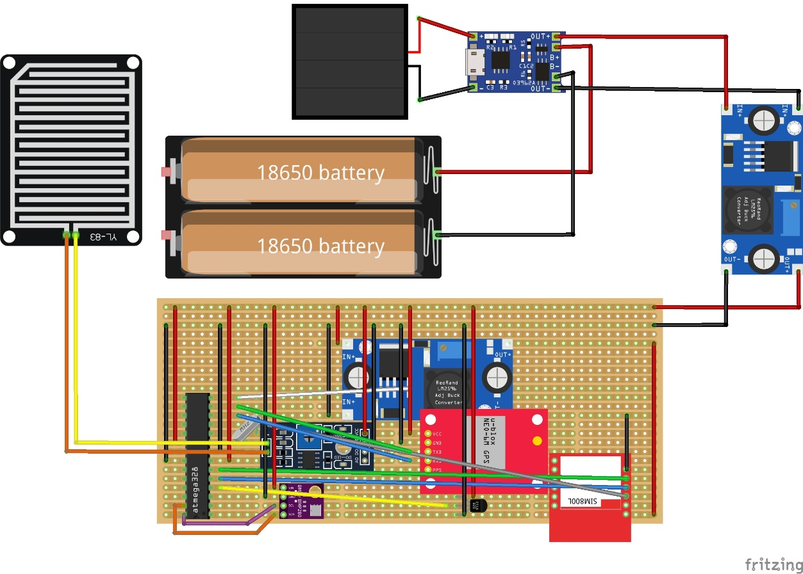

Figure - Prototype Design

The one drawback of the application is that it does not allow components to be displayed on a layer above the wires, making this diagram slightly messy. However, in the application, these drawbacks do not hamper use and this was a great reference point in building the prototype, allowing the ability to check the exact position of wires and components before soldering to the Veroboard. Figure 9 shows this finished prototype.

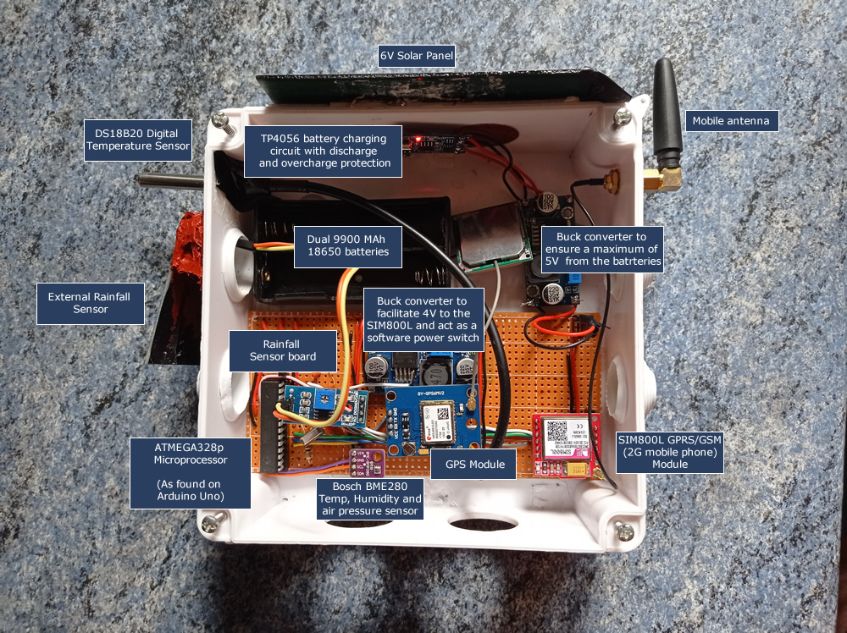

Figure - Prototype 1

## Understanding the Prototype

### Batteries

The batteries used were a pair of Rechargeable 18650 Lithium-Ion cells which are seated in parallel rather than in series. Batteries of this type can supply between 2.8V and 4.2V depending on the completeness of the charge on the battery. This voltage range is enough without needing to place the batteries in series, which would double that voltage range and by placing the batteries in parallel the capacity of the batteries is instead doubled ensuring a long time before the batteries are discharged. Both batteries are 9900 MAh (Milliamp Hours) and so have a very large capacity which is perfect for ensuring the weather station can remain functioning on cloudy days or overnight when there is no sunshine.

### Solar Panel

The solar panel used produces a peak of 6 Volts at 1 Ampere, this power range is very close to the power supplied by a USB charging cable and so is completely safe for use with the circuit and even if it should malfunction, this should not cause damage to other components.

The solar panel is connected to the exclosure using silicon sealant and the top holes on the enclosure have been used to thread the wires for the solar panel into the main cavity of the weather station. These holes were also filled with silicon to create a weatherproof seal. When deployed, the edges of the solar panel will be connected to the main body of the enclosure using waterproof tape which will stop any rainwater from sitting underneath the panel, however, this is mostly unnecessary as there are no uncovered connections to cause a short even if rainwater did get under the panel.

### TP4056 Charging / Battery Protection Circuit

The TP4056 is a circuit that features a USB socket for charging via USB, giving the option to manually recharge the weather station if this should ever be required. This circuit takes power from the solar panel and intelligently switches between this as a power source or the battery pack which is also connected to this circuit. The output of these is then fed to the main circuit board and used to power the weather station. This circuit also includes protection chips that mitigate the possibility of under-voltage or over-voltage on the batteries, helping to protect these and minimise the possibility of failure.

### Veroboard

The Veroboard was chosen for its large size and the fact that the back of the board has copper traces or lanes running horizontally between the holes in the surface. This makes for an excellent surface to solder to and also allows signals to be transmitted either by wires or by traces. This is extremely useful in creating data busses or power and ground rails, where multiple modules can be connected to a single trace without the need for individual wires.

### Enclosure

This enclosure was chosen because of its rugged construction and weather-proof design. Each side has two silicon inserts which can be removed if needed and by piercing these with heated needles, it is possible to attach sensors to the outside keeping a weatherproof seal. The ability to remove the inserts at the bottom will allow for the flow of air inside the weather station without the need to worry about water ingress. The corner columns which contain the screws for the enclosure also stop the board from getting too close to this bottom edge, giving some resistance to any potential splashes. Finally, the screw-on front cover has a silicon seal around the join and this seals the unit securely and stops rainwater ingress.

### Dual Temperature Sensors

It was identified early on that the internal temperature of a plastic box on a hot day, when the box is in direct sunlight would be higher than the outside temperature. This introduces inaccuracy in readings and also raises the possibility of heat damage to the components. The BME280 is used to read internal temperature to provide a means for identifying any potentially damaging temperatures inside the box. This can be thought of as a similar mechanism to the temperature sensors inside a modern PC which identify temperatures that are too high. A basic DS18B20 which is enclosed in an aluminium casing was introduced externally to record the external temperatures. The casing makes the sensor probe entirely waterproof and it can be fully submerged in water so this sensor is ideal for use outside.

### Rain Sensor

This basic rain sensor uses a large panel with two electronic traces on it which do not touch. As rain accumulates on the panel, the resistance of the board drops as the water effectively creates a short circuit. This drop in resistance is measured and acts as a measure of how moist the board is. This panel is secured to the outside of the box at a steep angle so that any rainfall does not sit on the board for long in an attempt to allow the board to dry out quickly once the rain has stopped, improving the readings taken.

### Buck Converter

These modules are a way of altering the voltage of a power source and due to the varying needs of the weather station components two of these were needed. The first acts as a booster to the battery power, converting the output of the battery to a steady 5V, required by the sensors and the Atmega328P MCU. In addition to this, another buck converter converts the 5V down to 4V for use within the SIM800L GSM module which requires a voltage of 3.4V to 4.2V which is not compatible with anything else on the circuit board and must for this reason be kept separate. On the module itself, there is a small screw that connects to a potentiometer which is used to tune the converter to the correct output voltage with the use of a multimeter taking readings off the output.

Buck converters use a set of two capacitors to store some of the current and so also help to smooth out any surges or drops in power. These modules also act as a type of power regulator, ensuring that the output voltage remains constant even though the current from the battery will slowly discharge with use.

### SIM800L GSM Module

This module is essentially a 2G module that used to be prevalent in a mobile phone. The device has a slot for a SIM card and can send SMS messages, connect to the internet using GSM and receive calls if connected to a speaker and microphone. The complexity of this device is not to be underestimated and communication with the device is achieved by sending individual commands to the device. There are a very large amount of commands available and learning how to communicate with this module was one of the largest pieces of work in the project.

This module is also orders of magnitude more power-hungry than the other modules used in this project. Most modules use less than 100MAh, however, the SIM800L uses 2A during transmission, which is 20 times the amount of power. This causes issues in terms of power supply as any chosen power supply needs to be able to supply that amount of power otherwise the module will reset every time that a transmission or network connection is made. Other modules cannot survive this level of power and so separate circuitry must be used to keep this module distinct from the rest of the weather station.

### Atmega328P Microcontroller

The microcontroller on an Arduino Uno is this chip and removing it from the board and using it on a breadboard has two distinct advantages that proved important for this project. Firstly, the Arduino Uno board has several circuits which are used for power regulation and other features that are not required in this project including the use of LED indicators for power, data transmission etc. These all have a power cost and essentially by removing the chip and using it on a breadboard, the power consumption is reduced which makes this application perfect for a battery-based device.

Secondly, there is the matter of price, with an Arduino Uno costing around £10, while the Atmega328p chip costs around £3 when buying since although bulk purchases can be made, increasing this saving. If buying the chip on its own, it is important to understand that an additional USB programmer will be needed to program the device but for this project, the original Arduino Uno board was used to program the chip. Either way, multiple chips can be quickly programmed with the same code this way, making it ideal for multiple devices or mass production.

### NEO-6M GPS Module

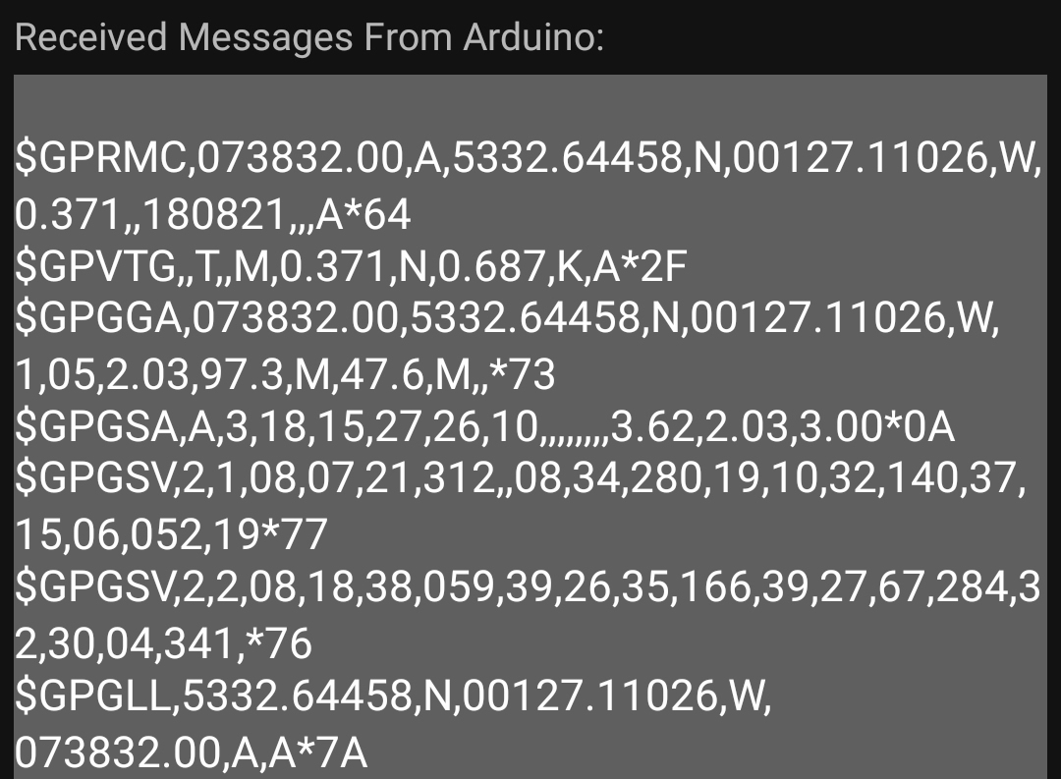

Figure - NMEA Sentences

This device uses a ceramic antenna to connect to satellites and to triangulate the position of the module using those signals to create National Marine Electronics Association sentences of which a sample is shown above in Figure 10. These are comma-separated structures that contain GPS positioning information and to collect this information and to give a position for the device.

## Software and Testing

This stage was mostly about consolidating the tests and software from the previous sprint and so there was more in the way of refactoring than any development for all but one of the modules. The decision was made to implement the weather station as a class which can be seen in Figure 7 and so some refactoring of the existing tests was implemented and the existing software was gradually ported over to the newly emerging class structure. TDD was employed throughout this and was used in the process of creating tests for the following key steps:

* All readings were moved into a single function that reads the measurements of all of the sensors. Once the basics of this passed the test, a struct was created to allow for easier storage and handling of these values and some additional functionality was added to the unit testing functions to allow for comparison of these structs.
* Testing was carried out on these results to prove that they all return values within the acceptable range of the sensor. This would provide automatic testing to some extent but visual checking of the results was implemented as well through some output text.
* Some power control functionality was added, allowing for the MCU to control the flow of power to other devices such as the sensors, this would allow these to be active only for the time taken to get readings and this would improve the life of the battery. Tests were written to verify this, checking the signal level of the wires where a High signal would indicate 5V and Low would indicate no power. This again was backed up by visually checking the power LEDs on the sensors.
* Validation routines were created for checking that the mobile number, ID and APN for the mobile network were all valid.
* Adding functionality to read, write and check the contents of the Electrically Erasable Programmable Read-Only Memory (EEPROM) which is used to store the mobile number, ID of the weather station and mobile network APN in non-volatile storage so these do not get erased when power is removed.
* Tests were set up to send an SMS and to retrieve test data from a web page using the SIM800L.

Except for the final SIM800L tests, development in this sprint went fairly well. A full set of test results from this sprint is available in APPENDIX 3 and it has to be said that the sensor modules have performed wonderfully throughout, however, the Sim800L and NEO-6WGPS did cause some issues that needed to be addressed and which took a lot more development time than anticipated, causing the project to slow down and forcing the introduction of a third sprint which was not originally planned for the hardware. In short, there were communication errors with the device, where the information returned was complete garbage and consisted of ASCII characters outside the normal range, there were also conflicts between modules meaning that communication would randomly stop with this module. On top of this, the program itself would randomly reset the entire weather station, strongly suggesting that either the underlying power circuitry was not supplying quite enough power and at peak times, or dynamic memory allocation was overwriting the contents of a section of memory in use by the program itself, causing the device to reset. These are discussed in more detail in the following sections

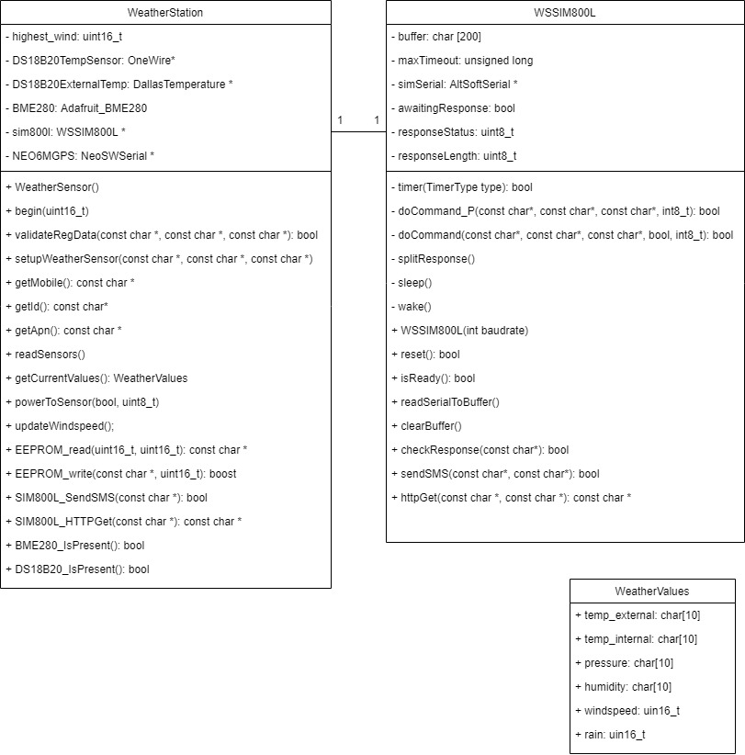

Figure - Class Diagram

## Issues in Sprint 2

### Library Issues

Fairly early on in this sprint, an issue cropped up with the use of the SoftwareSerial library, which is the default serial communication library. This issue only occurred when integration tests were being performed and more than one module was present and communicating with the MCU. This issue seems to be a problem with that particular library, due to the way it is coded, which makes the library fairly resource hungry as it needs to scan the ports for communication. This makes it impossible for 2 instances of the library to work simultaneously and a replacement library which uses the Arduino inbuilt interrupt timers was selected which resolved the issue. This is a great indication of why integration tests are so important since this problem would never occur in the individual prototypes and would only occur when multiple modules were introduced.

There were also some issues regarding the SIM800L libraries. All of these libraries are third-party and all handle the process of communicating commands to the module and reading the responses sent back differently. The SIM800L is a fully functional mobile device and there are many commands for power usage, making and receiving calls and more which is an incredibly rich set of commands yet at most this project needed to use perhaps 10 of those commands. Therefore introducing the full libraries had an impact on the available memory space and in the end, the decision was taken to understand how the various libraries worked and to recreate the part of these that were core to the specific functionality required in this. In doing so a separate SIM800L class was created to house the functionality which unfortunately impacted development time but also did resolve several smaller issues and resulted in a much smaller memory footprint overall.

### SIM800L Issues

The issues that occurred can be summed to some degree in the image of the output logs in Figure 12. It can be seen that while the first commands return a clear “OK” response, the following three commands all return a garbage set of characters. All commands in this particular set of code should either return “OK” or return “ERROR” if for example the HTTP functionality was already initialised and the command to initialise was sent but overall the results of these commands are fairly irrelevant so long as they are not a garbage string. After the 3 garbage commands, the system stops during a command sequence and then resets before reacquiring the sensor readings and starting the whole process again. This is before the command sequence has finished and at the time, a five minute counter should have been applied between readings so something was fairly wrong with the process.

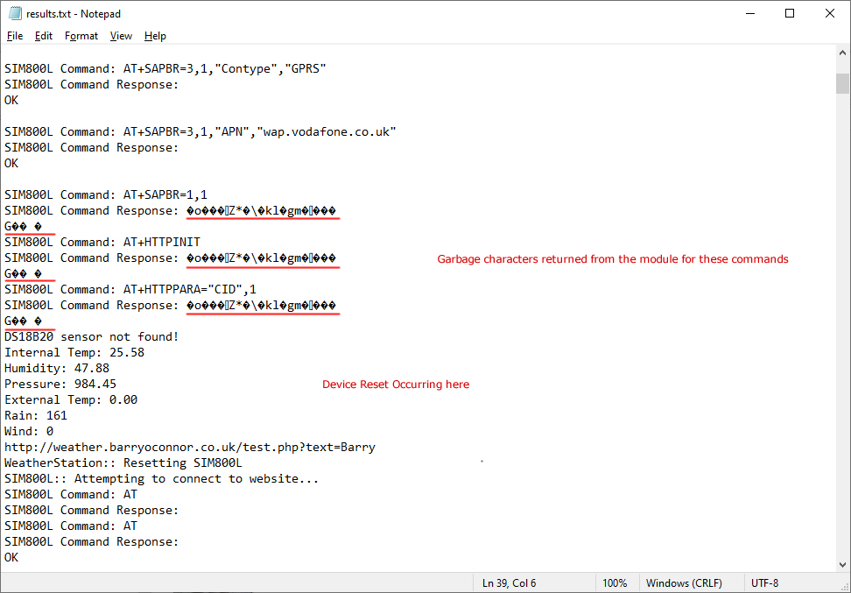

Figure - Output Issues Highlighted in Logs

### Dynamic Memory Allocation Issues

It’s relatively standard practice to use a String class for textual data in a C++ working environment. This class creates objects specifically designed to handle text and they are very successful in removing the need for programmers to deal with C-Style strings, which are simply arrays of the character type Char. The main difference between the two, the main reason programmers use them and the reason they should never be used on an Arduino program all stem from this. As discussed previously, memory on an Arduino falls into two main areas Program or Flash memory stores the compiled program code while the SDRAM contains objects, variables, function footprints and so on. Strings in C++If the developer were to choose a String, the class dynamic allocation of memory will eventually cause problems and will, in any project of sufficient size, eventually cause the program to stop working.

In C++ a string works internally as a C-Style char array but it can allocate memory dynamically, so as the contents fill the array, the internal procedure allocates a new memory region twice the size of the current length, copies the content to the new array and reassigns the new array to the variable, deleting the original array. In a normal PC, this is an extremely efficient wrapper that allows for fast and reliable memory allocation without the need for the developer to manually do so, potentially introducing errors. In the confined memory of an Arduino, this dynamic allocation would mean that for example, a string of 100 characters would, temporarily result in the original 100 memory bytes and an additional 200 memory bytes for the new string existing. While this seems a trivial amount of memory, 300 bytes is 15% of the total memory available and changing the contents of memory locations in such a compact space will at some point result in the overwriting of existing variables or some aspect of the Stack or Heap, causing program instability. This issue cropped up early in development thankfully and a complete switch was made to C-Style char array strings for this project.

One interesting point on the subject of strings is that the architecture of the Arduino allows for strings to be stored in the program memory, which on an Arduino is 32767 bytes, orders of magnitude bigger than the SDRAM. By using the available macros “F()” around hardcoded strings, and identifying constant strings with the PROGMEM keyword, the amount of memory taken up by simple message text can be drastically reduced. For example, in factoring in these changes, the size of SDRAM used was reduced from 96% down to 42%. This should be enough of a reduction to rule out the possibility of memory being corrupted.

### Communication Issues

In terms of the garbage response, two things stood out as possible issues the first being the possibility of interference on the wires. The wires on the circuit board which stretch between the SIM800L and the MCU are very long, approximately six inches and those with electrical engineering skills will know that the length of a wire can affect the signal on the wire with the signal degrading in proportion to the length of the wire. To test this and rule this out, it would mean moving the SIM800L closer to the MCU.

In terms of the reset, it always happened after a period of garbage response from the SIM800L and as mentioned previously, this module is extremely power-hungry and is known to reset if power is not sufficient. Upon considering this and checking the datasheets for the Buck Converter modules, it was noticed that the module between the battery and board had a peak throughput of 2A, which is exactly the peak value of the SIM800L meaning that there was a very real possibility that there simply wasn’t enough power getting through at peak to power both the MCU and this was resulting in a brownout. However, this garbage result and reset did not happen every time and occasionally the process would complete flawlessly for a few cycles and then it would repeatedly cause this problem so it wasn’t a cut and dry case that the power if it was at fault, was always cutting out.

## The decision to Introduce Sprint 3

In the end, a decision was made to use the knowledge gained from this sprint to rebuild the prototype from the ground up, using the knowledge about power issues, length of wire and interference to locate the MCU centrally on the board, reducing the length of the wires to an absolute minimum which would remove the issue of signal degradation. The Buck Converter was switched for a new one with a 5A maximum throughput and this would easily allow enough current to keep the SIM800L and the board powered throughout. Capacitors would be added to relevant areas, acting as a buffer to provide additional power for the split second a peak may happen, smoothing the power supply and helping to keep things running more steadily.

This board would also include some minor quality of life improvements including connector sockets to allow direct programming of the MCU simply by connecting wires to the board from the connector and the power devices would be included on the circuit this time, making the unit a little less clumsy.

While this step was very much going to impact development time, the SIM800L and indeed the ability to send data to the server was considered to be the most central functionality within the project. Without a working way to transmit the data, there would be no results to record and any work carried out on the accompanying website would essentially be wasted effort.

At this point it was conceded that prior electronics knowledge was key here and should the final prototype with the refinements listed above continue to cause issues, it would be time to admit defeat and the project would need to be reappraised with the input of someone more versed with electronics. As such, the development would essentially stop at that point since outside expertise would be needed to correct any outstanding issues.

## Sprint 3

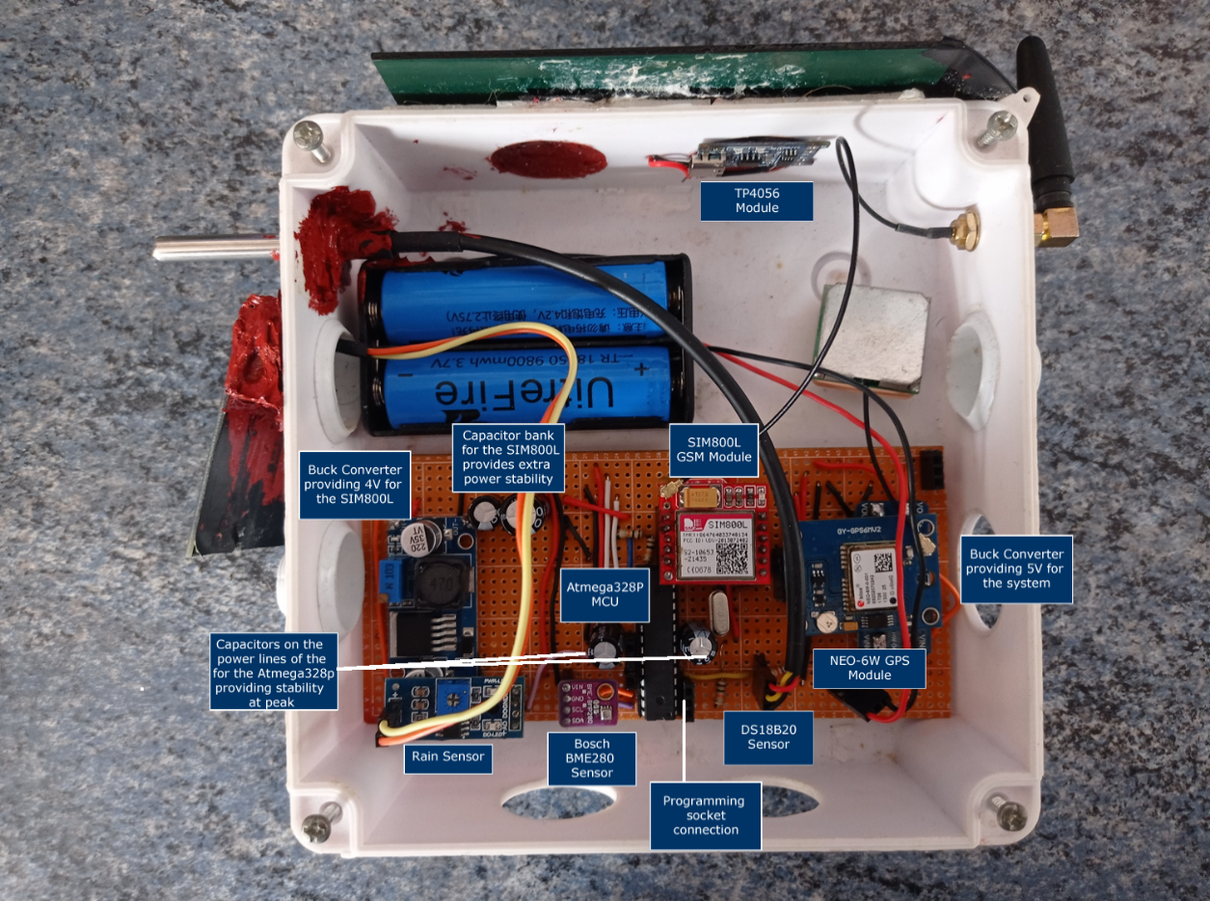

Figure - Improved Prototype Weather Station

This Sprint turned out to be a difficult one but did eventually end on a high note as an undiscovered issue was found with the SIM800L module.

When rebuilding the prototype in this final configuration, a great deal of care was taken to check voltages on all power points and to ensure that connectivity between various connections and the MCU was intact. With these all functioning normally and voltages being correct on an empty board, the various modules were added one at a time and checked for voltages and communication. The sole exception to this was the SIM800L module which was left until last since this was the module most likely to cause issues. As a testament to the durability of the sensor modules, all of these functioned correctly once connected to the board and produced results as expected. The SIM800L itself was not so cooperative as demonstrated in Figure 16 and the same communication issues were present.

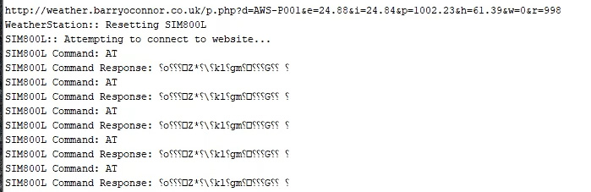

Figure - SIM800L Logs

This was essentially the killer blow to the project and at this point, preparations were made to record what results were possible and to admit defeat and chalk up the failure of the project as a lesson learned. However, in a literal Deus Ex Machina moment on the 19th of August (less than 24 hours before submission of this document) at approximately 9:15 pm, something very interesting happened.

### A Tale of Two Modules

During the early stages of Sprint Two, a mistake was made with a hot soldering iron and the original SIM800L module (Module A) which accidentally damaged the module. The damage was to the section of Module A which contains the antenna and this more or less destroyed the ability of the device to make a connection to the mobile network, which meant the chip was of no use and a replacement was purchased, this replacement (Module B) is the module with the intermittent fault, currently in the weather station while Module A was in a box of spares and random pieces of wire.

While running some tests on the evening and attempting to take footage of the weather station at least collecting data onscreen, Module B behaved very strangely and at one point went from garbage output (as seen in Figure 16) to complete a full submission cycle then returning to garbage and resetting. This was the same behaviour exhibited before but due to the testing of the circuit at all stages and the monitoring of voltages on the circuit board, this time it was certain that the power issues had been fixed and the power readings were as solid as a rock throughout the entire operation. This assertion had not been possible with the previous prototype which did not include the capacitor banks present in the final prototype. These capacitors act as a store for current and would charge up and release power to components in the event of any fluctuations in the power supply meaning that there could be no dips in power to the module causing it to reset.

Knowing that the power circuitry was functioning correctly and that the power was not causing the issue, Module B could potentially still have had communication errors on the wire but it could not reset due to power issues. This brought the realisation that Module B itself had an intermittent fault, potentially due to unforeseen damage during the project or at manufacture. Since Module B had always displayed this issue and due to the amateur understanding of the electronics, the assumption was made that the issue was more likely to exist within the prototype than Module B.

In an attempt to test this, Module B was swapped for Module A. Module A had lost the ability to connect to the internet, it was still responding normally to commands and so at the very least, it would offer some insight into whether the issue was specific to the Module B. If Module A responded to commands reliably throughout several attempts, it would be clear that the fault lay with Module B rather than the board.

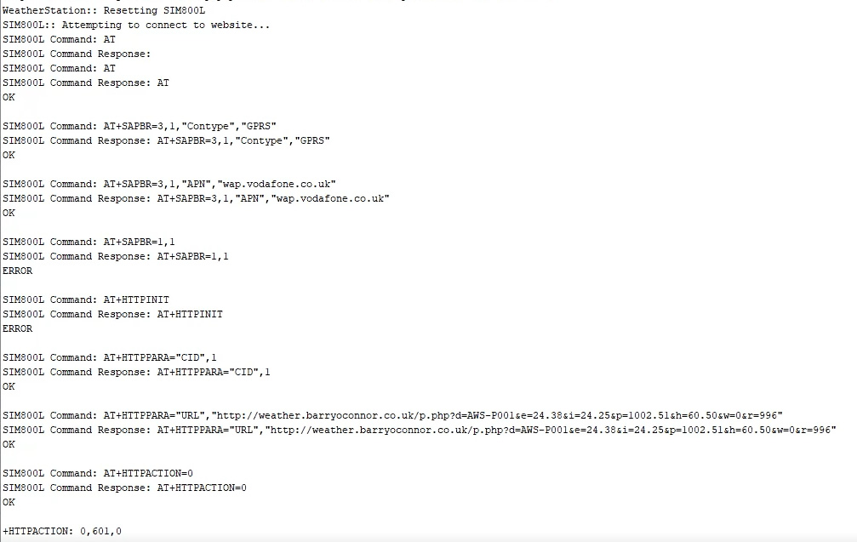

Figure - Original SIM800L Logs

With great relief, Module A repeatedly worked without any glitches in the communication stream. The connection to the internet was not possible due to the known damage to the antenna but Module A responded correctly and even displayed status of 601 during the operation. This status is reserved for “Network Issues” which is how the module is designed to notify the user of any network issues, so not only did the module work, it was correctly reporting the fact that it couldn’t connect to the mobile network. This confirmed the issue and at long last, proved that the issues could be resolved by the simple action of replacing the module with a fully functioning replacement. Unfortunately, this was simply not possible at this late hour since there was no time to order a replacement but this was a monumental moment and proved that the Weather Station itself was working correctly!

## Costings

The costings for the project will vary from day to day and the following are per item costings which will be more expensive than buying in bulk. The basket summary is included here and it is clear to see that the £60 budget is in fact enough to cover the cost of all materials used in the project except for a soldering iron. The full listing can be viewed in APPENDIX 5

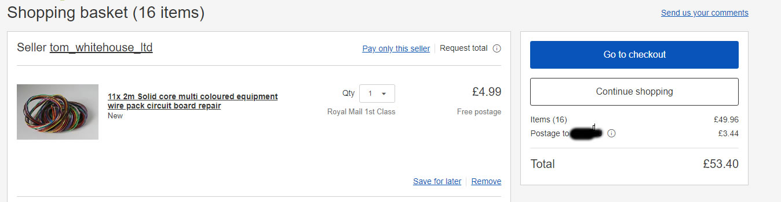

Figure - Costings Total



RESULTS / DISCUSSION

Introduction

This chapter will discuss the results gathered throughout the project and will focus on comparing these results to the aims of the project and highlighting whether the aims have been met or not. This will help to give an idea of whether the project was successful or not and to reason why this may be so.

## Results

### Investigating Whether the Hardware was Sufficient to support the Weather Station

The Weather Station and especially the MCU has been fairly reliable with the obvious exception of the faulty SIM800L and the Atmega328P MCU chip is a cheap, reliable, easy to use and feature-rich device. The only two drawbacks to this are very specific in that the chip only has 2018 bytes of SDRAM and it only has 3 interrupt timers, one of which was sacrificed for the increased reliability of AltSoftSerial in this project. Both of these could be completely circumvented by using one of the “Mega” family of MCU from Arduino as these are much bigger devices and have more I/O pins, more memory available and the availability of several interrupt clocks, however, they do come at a higher price which is why they were not chosen for this project.

This part of the project was perhaps the most complex and required a lot of changes to the code to maximise memory efficiency and ensure that both the code for the weather station and any variables and objects created would fit within the memory of the MCU. As discussed previously, there were some points during development where the memory became so fragmented that it caused abnormal program behaviour but with the careful analysis of every variable and the process of switching these to a variable type that used the exact memory required, this became possible. This was due in no small part to the use of the F() macro and the PROGMEM keyword which both allow for strings to be stored in program memory rather than in SDRAM. These strings can be retrieved later and copied into a suitable char array, which minimises the time where the string exists in memory. When all of these measures were implemented, the impact upon the SDRAM was significant and still leaves some room for future development. Figure 17 below shows the final usage for SDRAM to be at 46% and program memory to be at 70% which is well within the usable range for the Arduino.



Figure - Final SDRAM Usage

The placing of the MCU directly onto the circuit board proved to be an excellent one and this helped to reduce power consumption and the size of the overall project.

### Costings

As discussed in Chapter 4, the costings for the project amount to £53.40 at the time of writing which is under the £60 top end of the budget and makes the weather station meet the requirements for costings.

### Power

There was some concern about powering the device, however, this proved to be unnecessary. 9900MAh batteries were chosen and these have been repeatedly powering the device for approximately a week without any charge being applied to the batteries. The addition of the solar panel which generates 6V at 1A is essentially creating the same level of charging capability as a Fast Charge or Thunderbolt connection on a mobile phone and so the batteries can be charged completely in under 3 hours on a sunny day. This value will drop on overcast days, however, the solar panel does generate around 4V even on a fairly overcast day so it is likely that there will be no issue in keeping the weather station running for long periods.

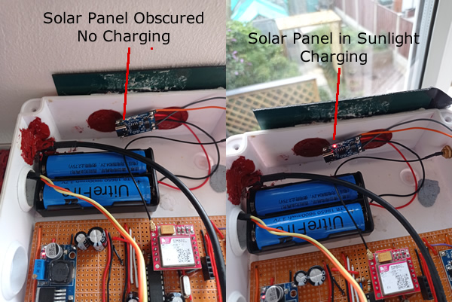

Figure - Demonstrating Charging via Solar Panel

### Weather Proof Enclosure

Care was taken to select a suitable, weatherproof enclosure and steps have been taken to make sure that any modifications have been sealed using silicon sealant to keep the device waterproof. The enclosure has been tested under a running shower (Figure 19) due to the very warm conditions this year and was also able to withstand the torrential rain that followed the heatwave in the UK. In both cases, there has been no sign of water on the inside afterwards. This can be seen in the following image which shows the weather station within the shower stream and afterwards with the areas where the water did collect highlighted, so some caution needs to be taken when opening a soaking wet weather station, but so long as the front cover is securely screwed in place, the seals hold and no water gets in.

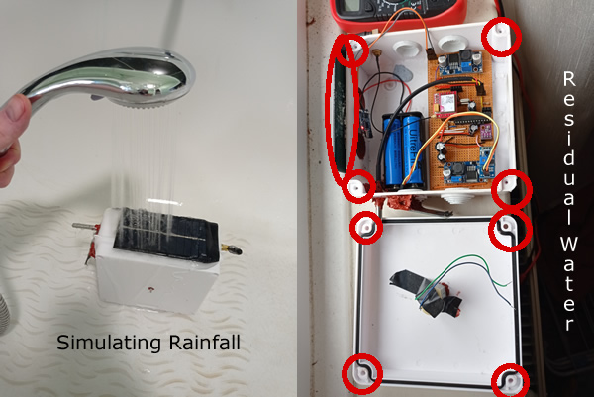

Figure - Simulating Rainfall and Displaying Areas Where Water Collects Externally

Care has also been taken to use special silicon used in car engines instead of the standard bathroom sealant variety. This type of silicon is red so it does spoil the look of the weather station slightly but it is also much more heat resistant than the standard. This heat resistance will help to stop the silicon from becoming damaged from the heat generated by the internal and external temperatures. The weather station itself takes temperature readings internally and externally and has dedicated code to send an SMS to the owner should these internal temperatures ever go outside of the safe range, specified by Arduino. This is to help farmers in hot countries monitor their weather stations.

All in all, the enclosure and sealant provides a robust, weatherproof enclosure for the device and it would have no issue being outside for extended periods provided the owner was careful to remove any residual standing water which can collect around the fastening screws. This shows that the objective concerning weatherproofing the weather station is successful.

### Collection of Data on the Server

Thanks to the last minute finding of the intermittent fault with the SIM800L module, the project takes a step closer to being a success in this respect. Although the results gathered have been somewhat intermittent, this was down to an intermittent issue with the SIM800L module itself. Thankfully, the module worked enough to have some entries in the database as can be seen in the image below. This also demonstrates variations in the values gathered, showing the changes in temperature, humidity etc over the period the device was active. Please note that some of the sensors were removed and tested as part of the focus on checking power consumption so, in some entries, a 0 is present instead of reading but this matches the device that was removed at the time and is expected. While this is not an ideal set of results with perfectly timed intervals, it does go a long way to prove that the core solution is sound and that the envisioned process can and does work.

This complements the previous sections and fulfils not only that the device can interface with a web server and store data but also reinforces the fact that the MCU is capable of handling the tasks.

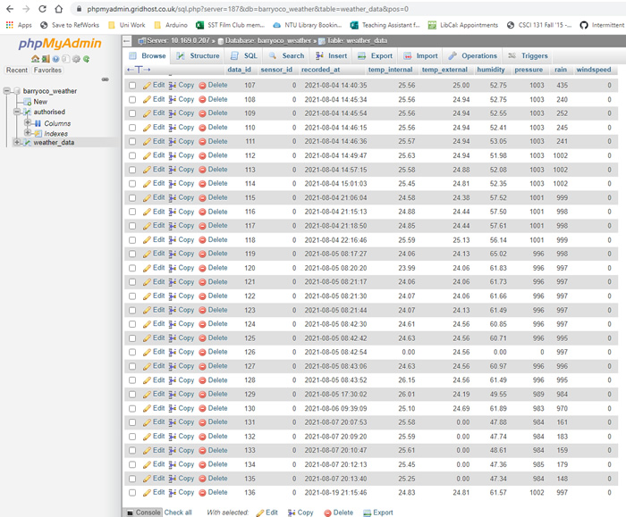

Figure - Captured Data in the Database



CONCLUSIONS / FUTURE WORK

## Conclusions

For a while, it seemed like the project was heading for failure which was a difficult thing to accept given the amount of work carried out on the project over the last several months. Upon finding the issue, several things became clear. Firstly there is a compunction to assume that third party software is of good quality and to find fault more readily in work created by yourself. Finding the intermittent problem was sheer luck and while part of that is down to the lack of expertise in electronics, some of that is due to not considering that a purchased device could have a manufacturing fault. On both occasions, it took some time to even consider that outside forces could be at fault and this caused delays in the project. It is somewhat disheartening to think of a weather station that benefitted from the early discovery of the SIM800L issue, which would easily have met all the criteria and would have had enough development time left over to create the web interface and possibly even have created some additional features in terms of analysis.

Part of working in a group is the ability to have group members from different backgrounds. In a professional project, it would have been extremely likely that the project would have had access to the input of an Electrical Engineer. With this background and with the input of other developers and potentially UI experts, the project would have been able to enjoy a smoother development cycle. This benefit is very obvious in this project, however, there is something to be said for the ability to take on entirely new and challenging projects and certainly, this project has reached a level of hard-earned success that evokes a sense of pride.

In terms of the aims of the project, these and the requirements have been met mostly. The issue of not completing the website due to the scope creep introduced by hardware issues is the one key area where the project has not managed to reach the goals set out. However, the project is in a very good position due to the extra work, which did improve the prototype and did solve several issues as well as adding some quality of life features. In the grand scheme, the creation of a website is fairly easy in comparison to the hardware and if there had been any development time left, a few days would have finished this one aspect off. Therefore it does not seem like the project is very far away from fulfilling that aim and for a project which started with almost total ignorance of hardware, this feels like a victory.

## Future work

While the project did have issues, these mainly centred around the choice of communication method and other aspects of the project showed much more potential. With a better, more reliable communication method, the project could certainly become a solid basis for improvement and become a valuable device. In terms of future work, just like with the project, the direction very much depends on which aspect of the development is the focus.

### Hardware Focus

#### Rain Gauge

In terms of hardware, some changes could be made moving forward and the addition of a rainfall gauge that essentially would use a “tipping bucket” system would improve the weather station. This would compromise an inverted T shape with a small bucket on each side which would function similarly to a child's see-saw. As the rain would collect on top of the unit, it would be funnelled down inside and would collect in one side of the inverted T. This piece would be fastened to a fulcrum bar and as the weight of the rain in one side increases, this side would sink while the other side rose. As the full side reaches the bottom, the inverted T would come into contact with a switch which would simply increment a counter and the rainwater would flow out of the bucket at the lowest position. This would repeat back and forth, counting the buckets of rainwater that would have previously been measured. Water is very simple to measure since 1mm = 1g so the contents of the bucket can easily be calculated and this constant would just be multiplied by the number of times the switches were triggered. For example, 100 switch activations with a bucket that contains 4mm of water would mean 400mm of rain had fallen.

#### Wind Vane

The addition of a wind vane to the weather station would be a useful addition as it would allow farmers to discover the predominant wind direction in the area and would allow for the construction of wind braces which could be used to protect more delicate crops. The price of a wind vane was too high for this project but the addition would be an improvement. This could be attempted by creating a disc with proximity sensors at the cardinal points and installing a central column with a flat piece of plastic at the top. As the wind blows, it would catch the plastic and turn it in the direction of the wind, which would trigger the proximity sensors as it passed by. This would give a good indication of the direction of the wind.

#### Production Improvements

While every attempt was made during the project to consider the possibility of mass production, the commissioning and design of printed circuit boards (PCB) was out of scope for the project. This service is readily available and many manufacturers exist who will create a PCB fairly cheaply. The main obstacle for this was the design of the boards themselves, which require the use of specialist software to create what is known as a Gerber file, which is a layered graphical representation of the circuitry present inside the PCB. A deeper understanding of electronics was required for this than available and so this option was discarded however, for the production of multiple weather stations this would remove some of the time taken to build. The PCB manufacturers also offer a service where chips and components can be pre-soldered to the board, meaning that many of the common components could be included for a little extra cost and this would vastly speed up the production time.

### Software Focus

#### Registration

This project didn’t have a focus on security as it was simply an early prototype however being able to post to a web server does introduce security concerns as someone could maliciously post data and ruin the contents. To combat this, the project introduced the idea of a per-unit ID which would be added to the “authorised” table and so some control could be had over which devices could post. This could be further enhanced by including a registration phase in the weather station when connected to a computer, which would allow the user to input their registration details and match the ID of the weather station to their contact details and account.

In addition, the communication method could be improved to use a POST rather than a GET which would have the added benefit of hiding the variable names from prying eyes and make it more difficult to guess the correct key-value pairs to use to pass data to the server. This could be yet further improved by the implementation of Secure Sockets Layer (SSL) and Hypertext Transfer Protocol Secure (HTTPS) to encrypt the communication between the weather station and the server.

### Data Analysis

The project stops short of analysing the data gathered by the weather station and this would be a very important area of future development and would add a lot of value to the system going forward. At the basic end of the spectrum, this could simply be monthly or weekly statistics about averages, low and high values for the data which would be displayed to the user. At the upper end, this data could be analysed in an attempt to spot trends in the weather. Perhaps after X days of heavy wind, a crop of coffee beans loses 50% of the beans and so the weather station could be used to provide warnings about trends to the farmer.

In a more predictive fashion, perhaps with enough data available over a long enough period a data analyst might be able to come up with a way of taking gathered data and using it to predict the weather for a period into the future. This, if reliable, would provide a great feature and would certainly add value to the weather station.

The use of calculated readings such as Wind Chill, which is a measure of how cold it feels when in a windy area, or dew point which is the point at which dew will form on plant leaves is an interesting area for future work and these may be calculated from the readings currently included in the weather station, potentially making greater use of existing measurements while adding to the overall value.

## Legal, Social, Ethical and Professional Issues

### Legal

The Code of Conduct states that members must “ensure that you have the knowledge and understanding of Legislation and that you comply with such Legislation, in carrying out your professional responsibilities.” (British Computing Society, 2020). The project attempted to understand and ensure that legal requirements relevant to the project were met.

Following the Data Protection Act 2018 (Department for Digital, Culture, Media & Sport, 2020), which covers most elements within the General Data Protection Regulation (GDPR), the project has made a concerted attempt to not store personal information beyond that which is completely necessary. As such, only the mobile number and APN required for messaging and internet services is stored and this is stored within the EEPROM of the device itself. this helps to protect the identity of the users since, even if a security breach were to happen on the server, the only information of value would be weather data which would only be useful in the region it was gathered.

In terms of the data generated, all users should be advised that there will be variation in readings due to the simple fact that the components used are cheap, mass-produced electronics and so adjustments may need to be made to improve reliability.

### Social

The BCS Code of Conduct (British Computing Society, 2020) states that “conduct your professional activities without discrimination on the grounds of sex, sexual orientation, marital status, nationality, colour, race, ethnic origin, religion, age or disability, or of any other condition or requirement” This diversity is key to the success of the project as the end-user was envisioned to be a farmer with a small plot of land who depended on the crop they produced for food or income. This requirement would entail considering the needs of farmers from all nationalities, socio-economic backgrounds and genders equally. Without this universal reach, the market for the product would be severely diminished and so this point was not only the correct attitude in terms of a social and moral standpoint, but it also had a direct impact upon the ability for the product to be sold.

It also states that (British Computing Society, 2020) members should “promote equal access to the benefits of IT and seek to promote the inclusion of all sectors in society wherever opportunities arise”. As with the previous statement, the project fully utilises this point and, on one level, the project was developed with the needs of many people in mind. As such, the core idea was that, depending on technical know-how, the end-user could fall into one of two categories. A non-technical farmer could buy a prebuilt weather station but a farmer who perhaps was comfortable with soldering or just wanted a challenge could follow the project and create their version of the weather station. The cost of components and the project as a whole was an important factor too and it is hoped that by considering this, the wealth of customers does not become a defining factor in the userbase.

Great care must be taken in the production of this product as it does target some of the most financially restricted people in the world. It was a driving factor to remember at all times that for a student in an essentially rich country, a £3 component equated to a cup of coffee but for a farmer with very little income, dependant on their crop that £3 could equate to a whole months income. While unfortunately there will always come a point where prices cannot be driven down anymore, it is hoped that the end product can be within reasonable grasp for most. This has the knock-on effect that the project must always strive to provide reliable, useful information and ensure that by investing into this product, that money, which may have been hard to come by, does not end up wasted on a product with outstanding issues of reliability.

### Ethical

Again, it is important to restate the trust and impact upon the finances of a very poor farmer the purchase of the weather station may have. potentially this could be many months worth of income and as such it is ethically vital to ensure that that investment is respected and rewarded with a reliable, feature-rich weather station that provides a good return on investment. To not do so would simply squander the income of some of the worlds poorest which, ethically and morally is abhorrent.

With affordability being such an important factor, some attempts should always be made to ensure the product is affordable to most. Should the product ever reach production, perhaps it could be possible to offer a tiered pricing system, making the price of the weather station proportional to the income of an average farmer in that particular country. This would allow slightly increased prices for richer countries to subsidise the cost somewhat in poorer countries. Or perhaps for every so many sold a percentage would be donated to farming co-operatives.

### Professional

The BCS Code of Conduct (British Computing Society, 2020) states that members should: “develop your professional knowledge, skills and competence on a continuing basis, maintaining awareness of technological developments, procedures, and standards that are relevant to your field.”. The project had a period of research into the background materials needed for the project including weather conditions, current markets and competitor analysis and the underlying technology used and these were used as a foundation for the project. Many new skills were learned during the project and these factors, therefore, fulfil this guideline.

It goes on to say that members should “NOT claim any level of competence that you do not possess.” and that members should “have due regard for the legitimate rights of Third Parties” (British Computing Society, 2020). The project was created with this in mind and all code was created by the author, except for default Arduino libraries and third-party libraries which are correctly referenced and attributed, giving regard to the developers of that software.

The code also states that members must “respect and value alternative viewpoints and, seek, accept and offer honest criticisms of work.” (British Computing Society, 2020). This element came into play through the interaction with various members of staff and the project supervisor during the duration of the project. Advice was sought from several sources and in every instance, this wide array of sources resulted in invaluable advice, whether that was positive or critical. By respecting different viewpoints and taking criticisms on board, a greater insight into the software, hardware and motivations of the user was gained.

Finally, the code suggests that we should “accept professional responsibility for your work and for the work of colleagues who are defined in a given context as working under your supervision.” (British Computing Society, 2020). This project did not involve a team but the point is still valid in the requirement for professional responsibility regarding the work and behaviour towards others during the duration of the project. This point came to focus during the project as the results were not as anticipated and a degree of responsibility for the choices made and changes in direction had to be taken. By taking ownership and responsibility for the project, any issues that arise can be fully investigated and solutions found rather than potentially trying to disguise them. This ultimately improves the software and the professional reputation of the developer.

## Synoptic Reflections

This project has truly been a reflection of the time spent at Nottingham Trent University and has pulled elements from several aspects of the course together in a way that was both unexpected and enjoyable. There has been a unique combination of factors influencing this project that has brought into focus the interplay of different modules and highlighted specifics that would not normally play a part in perhaps a more software-focused project.

In terms of the memory restrictions, this has given me an insight into the workings of the stack and heap that years of software development did not. When working with modern computers it is relatively easy to understand these concepts at face value and pay them very little heed. The same is true of the differences between C++ and C, and the memory restrictions within this project gave a deeper understanding of how and why memory issues occur and the great amount of control C gives in combatting this.

In terms of employment, this project has offered the ability to consider jobs that require knowledge of microcontrollers and by taking on board the information learned in the above issues, it is possible that these jobs would be suitable. In more general terms, the programming, research and project planning skills will be useful in any job and being able to discuss this and other projects will help to get across during an interview that the author is capable of these tasks.

In a broader sense, the use of the correct methodologies and testing strategies have proven to be of use, especially when dealing with an unknown project such as this. By selecting these on their ability to handle quick changes in requirements and provide the security of well-tested steps, some of the uncertainty has been removed and any progress was fairly quickly validated and backed up by testing. This made the process less daunting and is something to talk about in the interview as this feels like a very valuable insight.

ReferenceS

ADAFRUIT, 2021. Memories of an Arduino [online]. [Accessed Aug 14, 2021].

AHMAD, P., et al., 2020. Photosynthesis, productivity and environmental stress. First edition.. ed. Hoboken: Wiley.

ALLMETEO, 2018. Weather Station Solution Price Table [online]. [Accessed May 8, 2021].

ANAT ZAIT, 2018-08-12T07:22:41+0000. The Full Arduino Uno Pinout Guide [including diagram] [online]. [Accessed Aug 17, 2021].

BOSCH, n.d. Bosch BMP280 [online]. [Accessed Aug 17, 2021].

BRITISH COMPUTING SOCIETY, 2020. BCS Code of Conduct | BCS - The Chartered Institute for IT [online]. [Accessed 6 November, 2020].

DAUNICHT, H.-. and BRINKJANS, H.J., 1996. Plant responses to reduced air pressure: Advanced techniques and results. Advances in Space Research, 18 (4), 273-281.

DEPARTMENT FOR DIGITAL, CULTURE, MEDIA & SPORT, 2019. Data protection - GOV.UK [online]. [Accessed Apr 30, 2020].

HATFIELD, J., et al., 2020. Indicators of climate change in agricultural systems. Climatic Change, 163 (4), 1719-1732.

INTERNATIONAL TELECOMMUNICATIONS UNION, 2020. Digital Development Dashboard [online]. [Accessed May 4, 2021].

LAST MINUTE ENGINEERS, 2020. How nRF24L01+ Wireless Module Works & Interface with Arduino [online]. [Accessed 11 April, 2021].

LORA ALLIANCE, 2021. What is LoRaWAN® Specification [online]. [Accessed May 6, 2021].

METEOROLOGICAL OFFICE, 2021a. High and low pressure [online]. [Accessed May 4, 2021].

METEOROLOGICAL OFFICE, 2021b. Observations [online]. [Accessed Apr 27, 2021].

NFU MUTUAL, 2021. Farming Insurance [online]. [Accessed 13/07/ 2021].

PERI, P. and BLOOMBERG, M., 2002. Windbreaks in southern Patagonia,Argentina: A review of research on growth models, windspeed reduction, and effects oncrops. Agroforestry Systems, 56 (2), 129-144.

PRODATA WEATHER SYSTEMS, 2015. Weather Stations Buying Guide [online]. [Accessed Aug 20, 2021].

SCHNEIDER, L., COMTE, V. and REBETEZ, M., 2021. Increasingly favourable winter temperature conditions for major crop and forest insect pest species in Switzerland. Agricultural and Forest Meteorology, 298-299.

TIBBITTS, T.W., 1979. Humidity and Plants. Bioscience, 29 (6), 358-363.

VISSER, E.J.W., et al., 2003. Flooding and Plant Growth. Annals of Botany, 91 (2), 107-109.

WANG, X., et al., 2015. Drought priming at vegetative growth stages improves tolerance to drought and heat stresses occurring during grain filling in spring wheat. Plant Growth Regulation, 75 (3), 677-687.

WORTH, A., 2021. A Complete Overview of 2G & 3G Sunsets — 1oT - Global Cellular Connectivity for IoT [online]. [Accessed May 5, 2021].

WRIGHT, A.J., et al., 2017. Plants are less negatively affected by flooding when growing in species-rich plant communities. The New Phytologist, 213 (2), 645.

Appendix 1 – Gantt

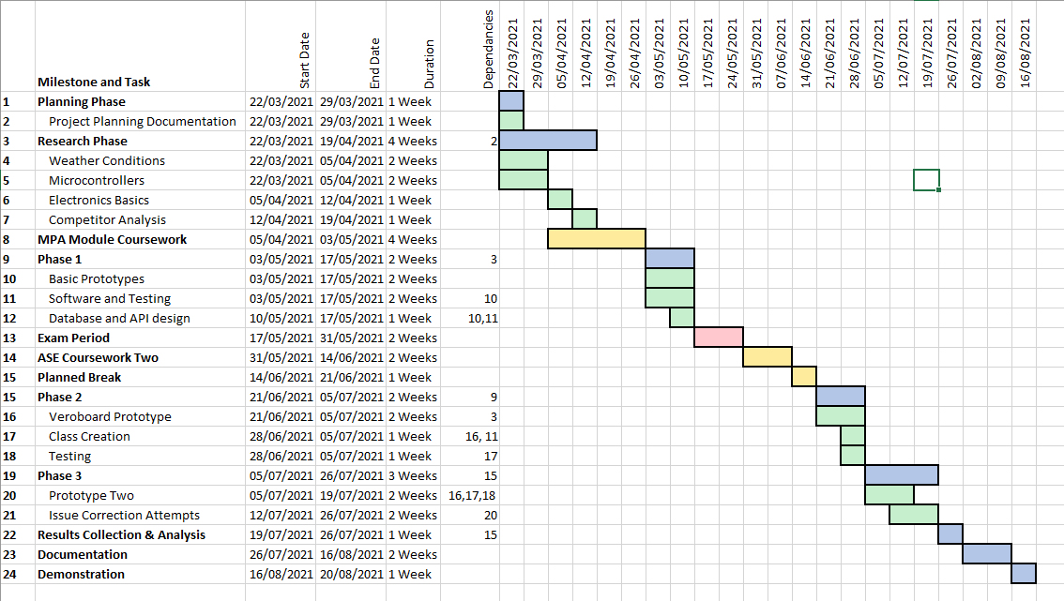

Appendix 2 – Schematics

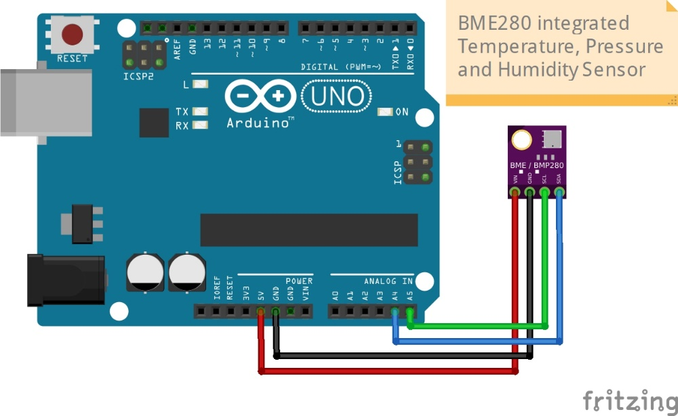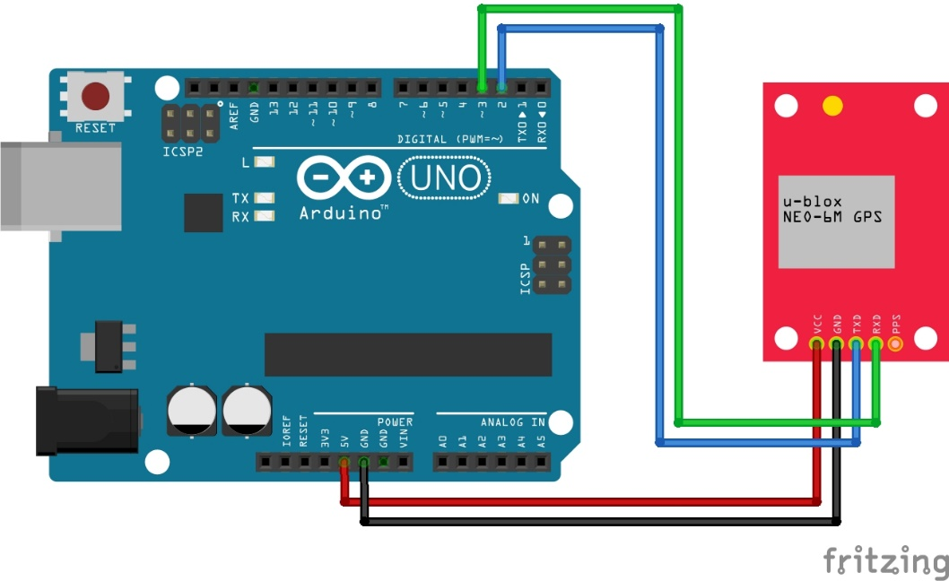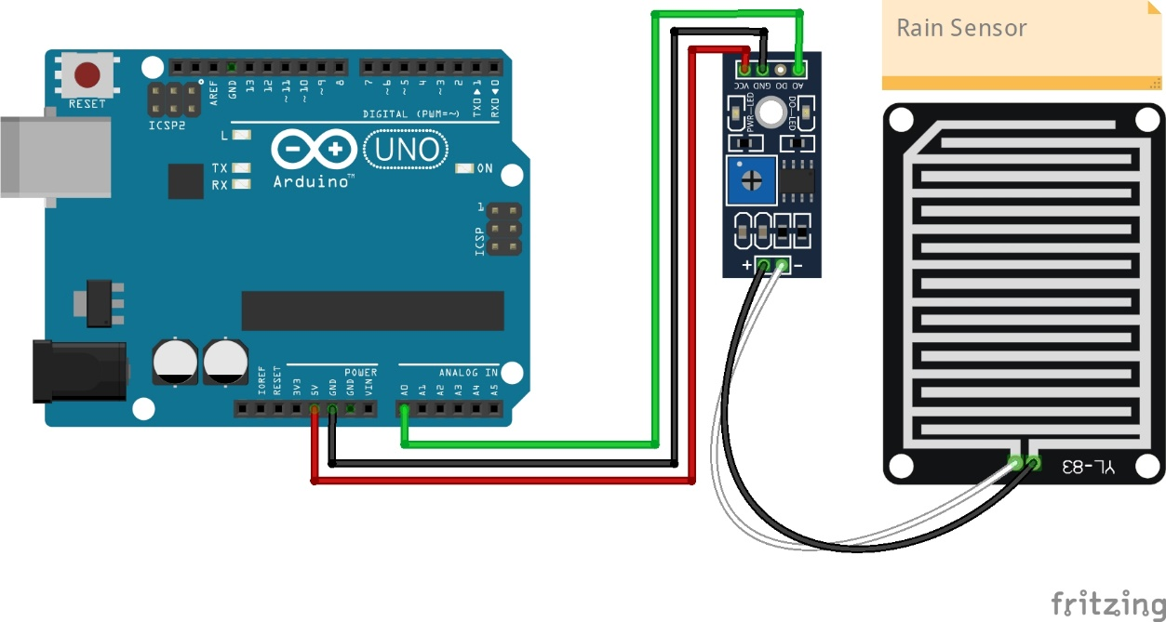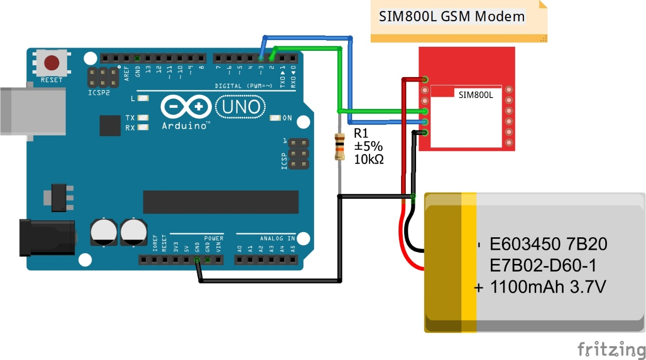

Appendix 4 – Diagrams

Appendix 3 – test Results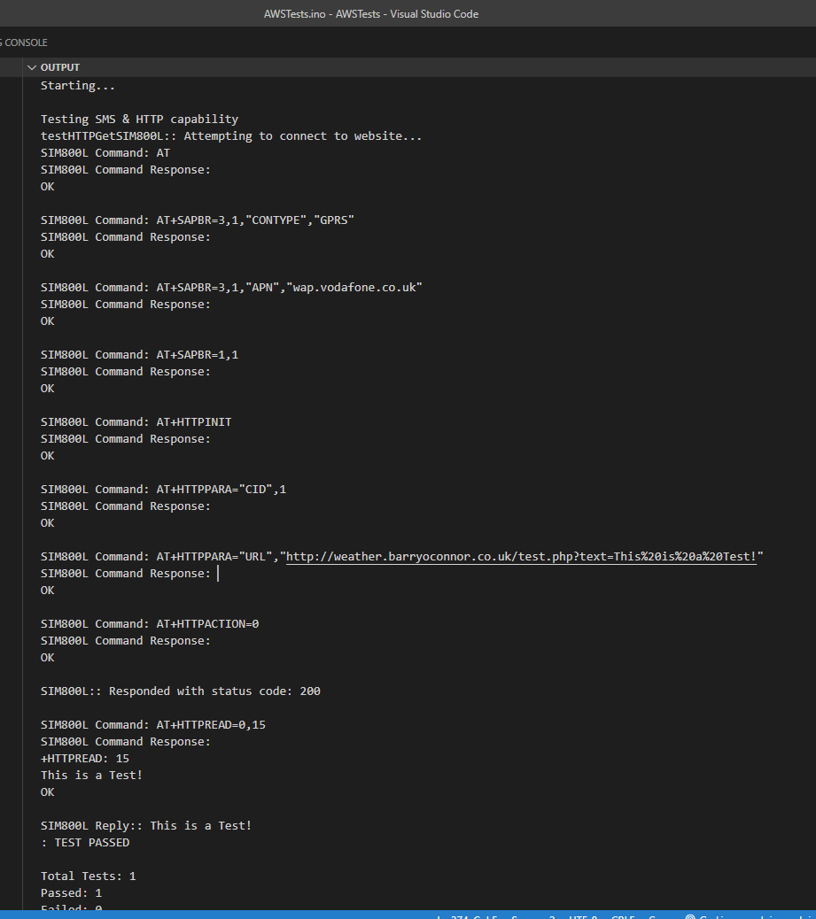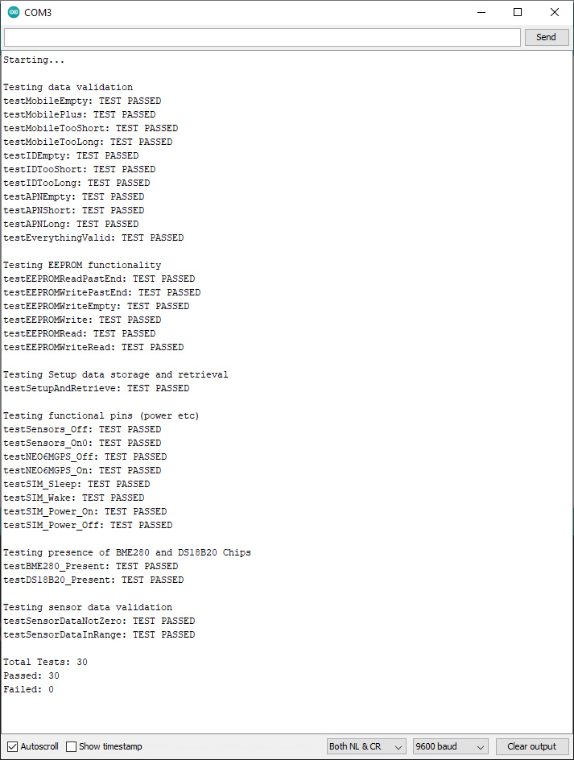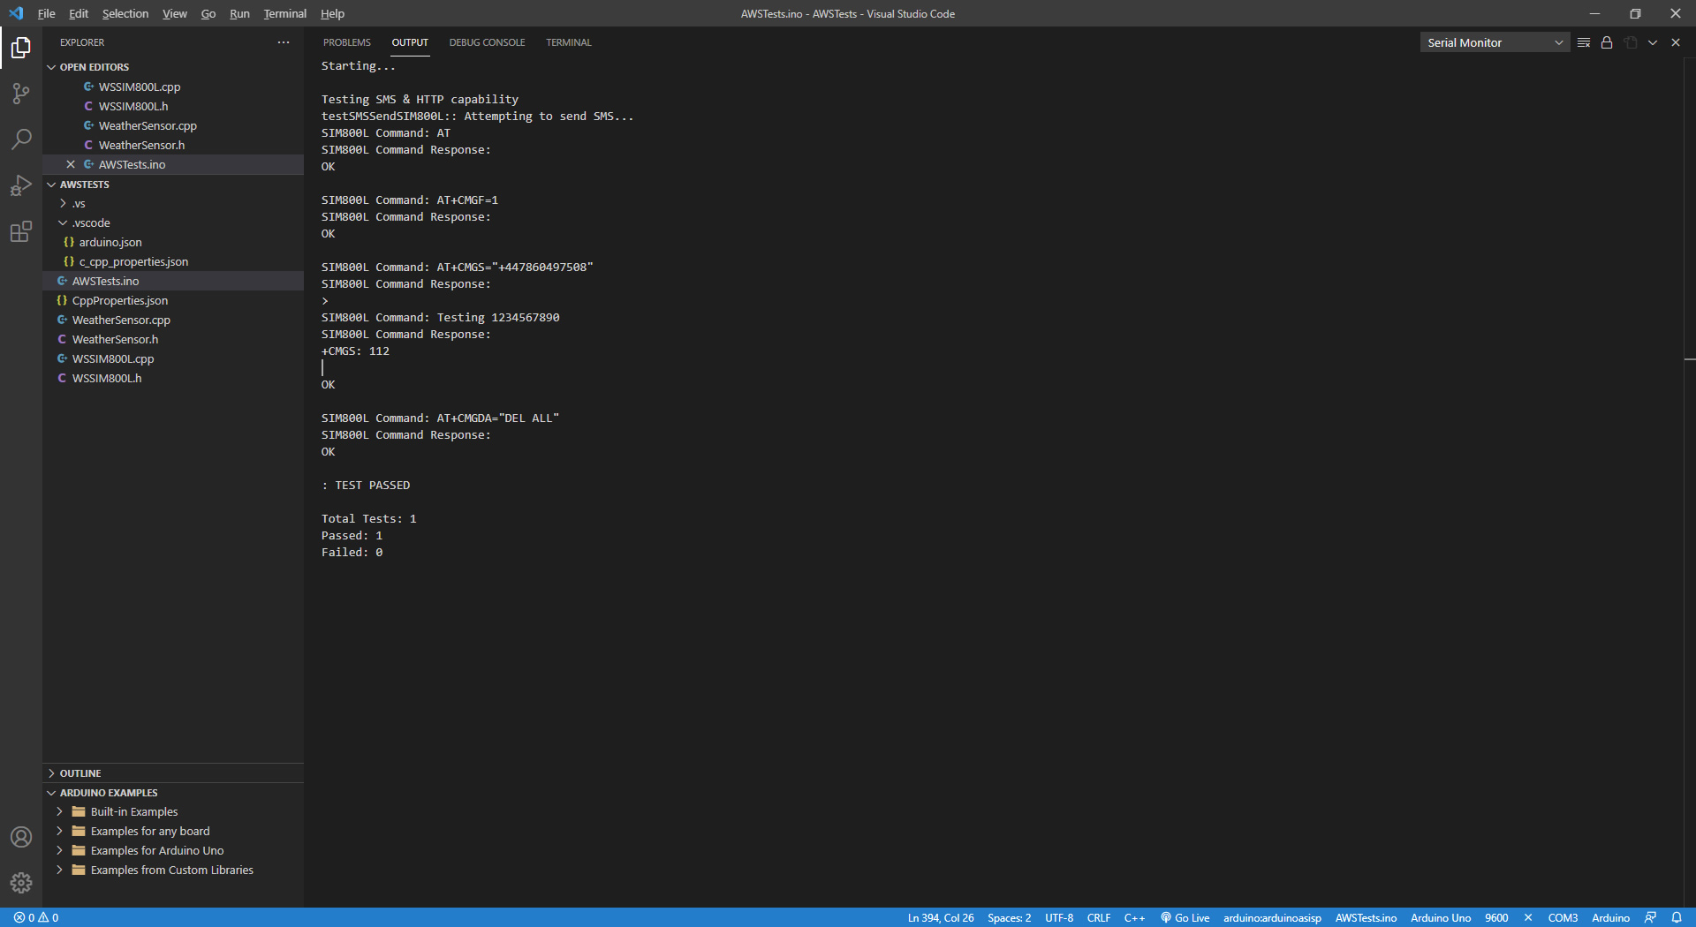

Appendix 5 – Costings